MOHAMED
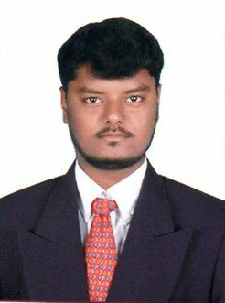
MOHAMED.330074@2freemail.com

CAREER OBJECTIVE

To work in a good and competitive environment, distribute my experience and efforts for the organization and personal development. I found myself ambitious, proactive self motivated and willing to assume responsibility.
EDUCATIONAL QUALIFICATION

Bachelor of Commerce (B.Com) ‐ First Class A+ Grade (2014)
Govt. Arts College (Bharathidasan University, India)

Master of Business Administration (MBA) ‐ First Class A++ Grade (2016)
Faculty of Finance
RDB College of Arts & Science (Bharathidasan University, India
(Affiliated by NAAC, India)

Diploma in Computer Application - 2008

WORK EXPERIENCE

Fresher - Seeking for position of Accountant Assistant/ Jr. Accountant

DUTIES & RESPONSIBILITIES

As assigned by the Management & the Organization

- Working with spreadsheet, sales and purchase ledger and journals
- Preparing statutory accounts
- Calculating and checking to make sure payments, amounts and records are correct.
- Sorting out incoming and outgoing daily post and answering any queries.
- Managing petty cash transaction.
- Controlling credit and chasing debt
- Reconciling finance account and direct debts
- Preparation of financial reports.
- Receiving and processing all invoices, expense form and request for payment
- Maintains accounting controls by preparing and recommending policies and procedures.
PERSONAL STRENGTH & SKILL

- Strong understanding of the workings of an office
- Excellent inter personal skills to deal with customer and external contacts
- Good organisational skills and ability to work and sometime implement own process
- Great patience
- Willingness to learn
- Adaptability to the job environment
- Optimum utilize of time with best use of knowledge & technology
- Ability to deal with people diplomatically

SEMINARS AND TRAININGS

- One day International Seminar on “Challenges of Business Leaders”
- Two days Workshop on “Personality Development”
- One day International Seminar on “Capital Outsourcing – Prospectus & Challenges”
- Project presentation on “Expansion of Export Credit in Foreign Currency”
PERSONAL DETAILS

Driving License | Valid India driving license
Religion & Marital Status | Islam & Single
Residence address | Sharjah
Languages Known  DECLARATION | Tamil (Re, Wr, Sp), English (Re, Wr, Sp)

I hereby declare that the details furnished above are true to the best of my knowledge.

MOHAMED

