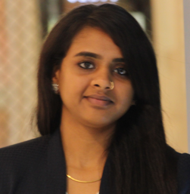
Smrithi

Smrithi.330686@2freemail.com

Profile Summary
- Innate leader with good communication, coordination skills and the ability to work in ever changing landscape.
- An adept retail management professional from Birla Institute of Management Technology
- A proficient IT engineer with comprehensive exposure to core areas of computer science and strong understanding of communication engineering

Objective

To build upon my retailing skill sets in a dynamic organization that gives me opportunities to evolve by contributing to continued growth and success of it

Work Experience

Jan 2017- Till Date
MRS PACKAGING LIMITED
Assistant Purchasing Manager
Responsibilities
- Handling the complete procurement process of MRS packaging limited, a leader in providing highest quality concession and catering equipment, food supplies, disposable packaging products to food and beverage industry in the middle east, Asia and Africa.
- Demand planning to ensure right availability of products based on forecasting techniques and by considering demand volatility.
- Managing lower inventory value and having high inventory turns.
- Using ERP system (NETSUITE) to optimize supply chain process.
- Cost optimization.
- Negotiating with various suppliers from U.S, Europe and Asia.
- Coordinating with logistics department for smooth import process.
- Monitoring the performance of critical products on day to day basis

July 2016-Dec 2016
Homecentre, Landmark Group
Trainee Store Manager
Responsibilities
- Maximize the sales of furniture/household department(s) by effective leadership, support and guidance to supervisors, sales associates and other stakeholders
- Analyzing retail metrics including ATV, basket size, conversion, sales/sq. feet and LFL
- Ensure accurate stock merchandise and management of stock, space, stock-loss, ageing items within the store
- Monitor and continuously seek to understand commercial environment, local trading patterns, competitor activity and market trends in retail sector
- Maintain high standards of visual appearance throughout the store inclusive of non-retailing areas
- Understanding stock-take procedures and participate in half-yearly stock audits
Accomplishments
- Created an evaluation matrix for Homecentre’s reward and recognition program
- Formulated and implemented customer engagement activities that included product demo, on-spot events for various occasions
- Standardized back store process which included asset tracking of products.

Industry Academia Interface

April 2015-July 2015
ECOM Express
Intern
Responsibilities
- To study and understand complete operations of ECOM Express; a 4 year old company which provides dedicated logistics services for booming ecommerce industry in India
- Standardizing the process pan India to increase operational efficiency and maintain service quality

Accomplishments
- Increased operational efficiency lead to improved service quality and prevented losses
- Developed a process manual titled “A small step before giant leap” which was also incorporated into training cell as a substitute for intense training program
- Received the coveted accolade “Gladiator Award” for performing beyond expectations from senior management of ECOM Express

Nov 2014-Dec 2014
Reliance Trends
Responsibilities
- Analyzed feedbacks of over 200 customers to accelerate the retail metrics and provide customer delight
Accomplishment(s)
- A proposal to increase the range and assortments had been submitted to store management as customer responses indicated absence of same

July 2013-July 2013
DSM Soft
Responsibility
- To strategize concepts for increasing customer engagement levels with their website through search engine optimization and developed a cost effective proposal for implementing digital marketing tools to generate sales

Academic Credentials
June 2014- March 2016
PGDM-Retail Management
Birla Institute of Management of Technology, India
- Completed post-graduation program with a CGPA of 8.87 and was recipient of prestigious Pujya Shri G.D Birla Scholarship for Academic Excellence
- Being a go-getter, got selected as a class representative for retail management group; created a liaison between college management and students for speedy solving of concerns
- An active member in Retailia, a forum for sharing ameliorations in retails sector were discussed and various industry experts were invited to address students
- Being an Executive Manager for Alumni Conduit, I was responsible for establishing nexus with 2500 alumni and was instrumental in launching an annual event for alumni christened as “Reflections”

Jan 2015-April 2015
Semester Abroad Program
Kedge Business School, France
- Was selected for student exchange program to Bordeaux, France and had been exposed to international brands and their retail operations
- Comprehensive hands on experience was instrumental in being a catalyst towards developing insights on luxury retailing
- The academic sessions were very pragmatic and comprehensive which taught process oriented approach

Aug 2010-April 2014
Bachelor of Engineering- Information Technology
Saranathan College of Engineering, Anna University, Trichy
- Completed internship at CNN News 18 (formerly CNN-IBN) where I had to understand broadcasting network and work with system maintenance team managing daily operations
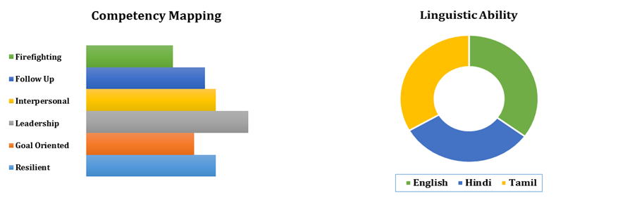
- Participated in Rotary Youth Leadership Awards’10 conclave held at Pondicherry which primarily focused on developing interpersonal and communication skills

