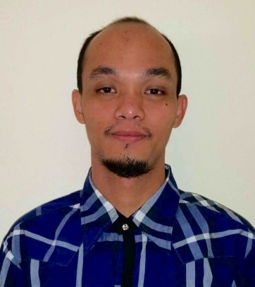
CURRICULUM VITAE
SHOJI
Email: shoji.330775@2freemail.com

PROFESSION : Information Technology
NATIONALITY : Filipino
LANGUAGES : Tagalog, English
EDUCATION : Bachelor of Science in Information Technology
Brokenshire College - Davao City, Philippines
School Year: 2004 – 2008

CAREER OBJECTIVE

I seek the challenging position which suits to my qualifications and experiences where I can best use my interpersonal skills to service the costumers. Good moral character, friendly and can interface with all level of organization.

SPECIAL SKILLS

- Knowledgeable in Windows application software (Excel / Word / PowerPoint/Access)
- Knowledgeable in Adobe Photoshop editing and graphic designing.
- Software and hardware troubleshooting(Installation/reformat/Assemble)
- Computer Networking and maintenance
- CCTV/IP Camera installation

WORK HISTORY

2014 JAN – 2016 AUG MUNICIPALITY OF A.O. FLOIRENDO
PANABO CITY, PHILIPPINES
IT SUPPORT / ENCODER

2012 AUG – 2013 DEC OCTAGON COMPUTER STORE
TAGUM CITY, PHILIPPINES
SALES ASSOCIATE

2009 JUN – 2012 JUN CC – JRC LINER INC.
PANABO CITY, PHILIPPINES
IT SUPPORT

DETAILED SUMMARY

2014 JAN – 2016 AUG MUNICIPALITY OF A.O. FLOIRENDO
PANABO CITY, PHILIPPINES
IT SUPPORT / ENCODER

Duties and Responsibilities:

- Thorough knowledge of operating systems, networking, hardware, software and troubleshooting issues.
- Explain problems and solutions clearly to the non-technical users.
- Responsible for setting up work station, internet connection and networking to landline set-up
- Fixing equipment, including printers and scanners, testing and servicing equipment.
- Prepare, compile and sort documents for data entry.
- Check source documents for accuracy
- Verify data and correct data where necessary.
- Enter data from source documents into prescribed computer database, files and forms.
- Transcribe information into required electronic format.
- Scan documents into document management systems or databases.

2012 AUG – 2013 DEC OCTAGON COMPUTER STORE
TAGUM CITY, PHILIPPINES
SALES ASSOCIATE

Duties and Responsibilities:

- Explain product features and warranty agreements
- Provide information on daily deals and promotions.
- Respond to customers’ requests and concerns in a resourceful manner.
- Assist customers by taking down products that may not be easy to reach.
- Demonstrate the working of a product when required.
- Provide customers with product information that they need.
- Ensure that all purchased items are delivered to the customers in a prompt manner
- Proactively ask customer how they can be assisted.

2009 JUN – 2012 JUN CC – JRC LINER INC.
PANABO CITY, PHILIPPINES
IT SUPPORT

Duties and Responsibilities:

- Loads software programs/packages and utility applications, installs operating systems.
- Install work station for new staff and explain the user friendly function.
- Demonstrate complete uses of the software being installed to staff pc.
- Follows maintenance schedule regularly to keep the work station free from virus threat.
- Setting up printers, scanners connection for all staff in the office
- Review and evaluate new software before installing in the system.

PERSONAL INFORMATION
BIRTHDATE : 02 June 1987
BIRTH PLACE : Panabo city, Philippines
CIVIL STATUS : Single
VISA STATUS : Visit Visa

Academic Credentials will be provided upon your request.

