RESUME
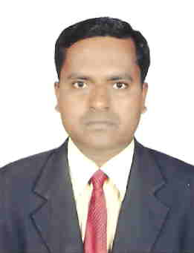

Applying for : ELECTRICAL FORMAN/SUPERVISOR

Personal Details:
Name | : | Riyajul
Nationality | : | Indian
Religion | : | Islam
Email ID | : | riyajul.330777@2freemail.com
Place of Issue | : | Muscat
Date of Birth | : | 26.01.1978
Language | : | English, Hindi and Urdu

Qualifications :

- B. A. ( Economics, English, Education ) from Dr. R.L.A.U. [Faizabad] Uttar Pradesh in the year of 1998.

Technical Qualification:
- I.T.I. in Electrician from State Industrial Training Institute from [U.P.] year 1998 to 2000 with passed by 80%.
Apprentice Training(NCVT):
- Training in ‘U.P. Power Corporation Limited, 400 KV. Sub Station Sultanpur.’ From 13 Sept. 2002 to 12 Sept.2004.
Additional Qualification:
- Diploma in Computer Application from ‘Kamla Nehru Institute of Information Technology Sultanpur’. From 2000 to 2002 as (Ms Word, Ms Excel, Powerpoint, Multimedia, Internet.)
Experience :
- Workin for SPECIALIST SERVICES LLC DUBAI UAE, as a Electrical chargehand from 23 March. 2014 to till the date.
- Worked for DRAKE & SCULL INTERNATIONAL LLC OMAN, as a Electrician from 27th Dec. 2011 to 20th Nov. 2012.
- Worked for TRANS GULF ELECTRO-MECHANICAL L.L.C. Dubai UAE, as a Electrical Chargehand from 26th June, 2010 to 27th Oct, 2011.
- Worked for ETA “Emirates Technical Associates” Dubai, U.A.E. as a Electrician from 01 June 2006 to 24th Jan, 2010.
- Worked for “National Power Controls” India as a Electrician from 15 Jan. 2005 to 02 Jan. 2006.
Job Profile:
- We have minimum 10 years working in Experienced Electrician & also able to work as a Chargehand & Foreman. We have the ability to work as Electrician, Installation, Maintenance & Repair on Electrical equipments. We have experience on Industrial and Residential cable, conduits related works, Pvc & GI conduits and Tray & Trunking works, Low Voltage, High Voltage, Power, Lighting wiring, also Intercom & Fire Alarm wiring and Instrumentation Cable laying experience, Motor, Star Delta & DOL Starter, Mcc, Elcb, Mccb, Acb & Cable dressing, glanding, termination, meggering, continuity Testing work etc.
I hereby declare that all the information given above are true and correct to the best of my knowledge and belief.

