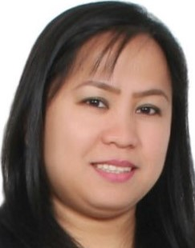 REBECCA
REBECCA.330832@2freemail.com
CUSTOMER SERVICE in HOSPITALITY and RETAIL INDUSTRY

- National of Philippines
- Living in Al Satwa, Dubai, United Arab Emirates
- Spent most career life in United Arab Emirates
- Fluent in English
- Proficiency in Microsoft office(word, excel, outlook/emails)
JOB EXPERIENCE
My experience for more than 6 years in customer service in Hospitality and being a Store Supervisor in my latest job which gave me excellent experience in dealing with different types of personalities, suppliers and facing top management, facing customer demands and complaints gave me confidence that I can do better for any role that suits my knowledge and experiences for my career growth within the company.
I am a computer literate, although I don't have a degree or certificate, I am confident that I am fit for the job role. I am flexible, willing to learn and fast learner with pleasing personality and willing to face new challenges. I am an organized person, and motivated person, always positive, dreamer and hardworking.

Last and Longest Job
Retail supervisor - Milk and Honey Gourmet Grocer Nov 2010 - Dec 2016
My duties and responsibilities
- Purchasing goods from Supplier follow up orders, making store reports, stock monitoring, expiry monitoring, selling area and staff supervising.
- To help and motivate my team to achieve the sales target.
- Responsible as liaison between customers and the company, keep records of customer interactions and transactions, details of inquiries, complaints, and comments
Nando’s Restaurants U.A.E. LLC September 2007 – October 2010 waitress/ cashier

Duties and responsibilities:
- Cashiering, welcoming and guiding guest to the sitting area.
- Issuing menu and taking the order & serving drinks and food to the guest.

Isabela hotel (Isabela, Philippines.) February 2004 – April 2005
Position: Receptionist

Duties and responsibilities:
- Deliver excellent customer service at all times.
- Assist and Deal with all enquiries in a professional and courteous manner in person or over the telephone.
- Fulfill all reasonable requests from guests to ensure satisfaction.
- Report any maintenance issues immediately to line manager and provide reports as required.

EDUCATION
- Diploma / High School
- From Dona Aurora National High School Philippines
- Graduated in 1998

