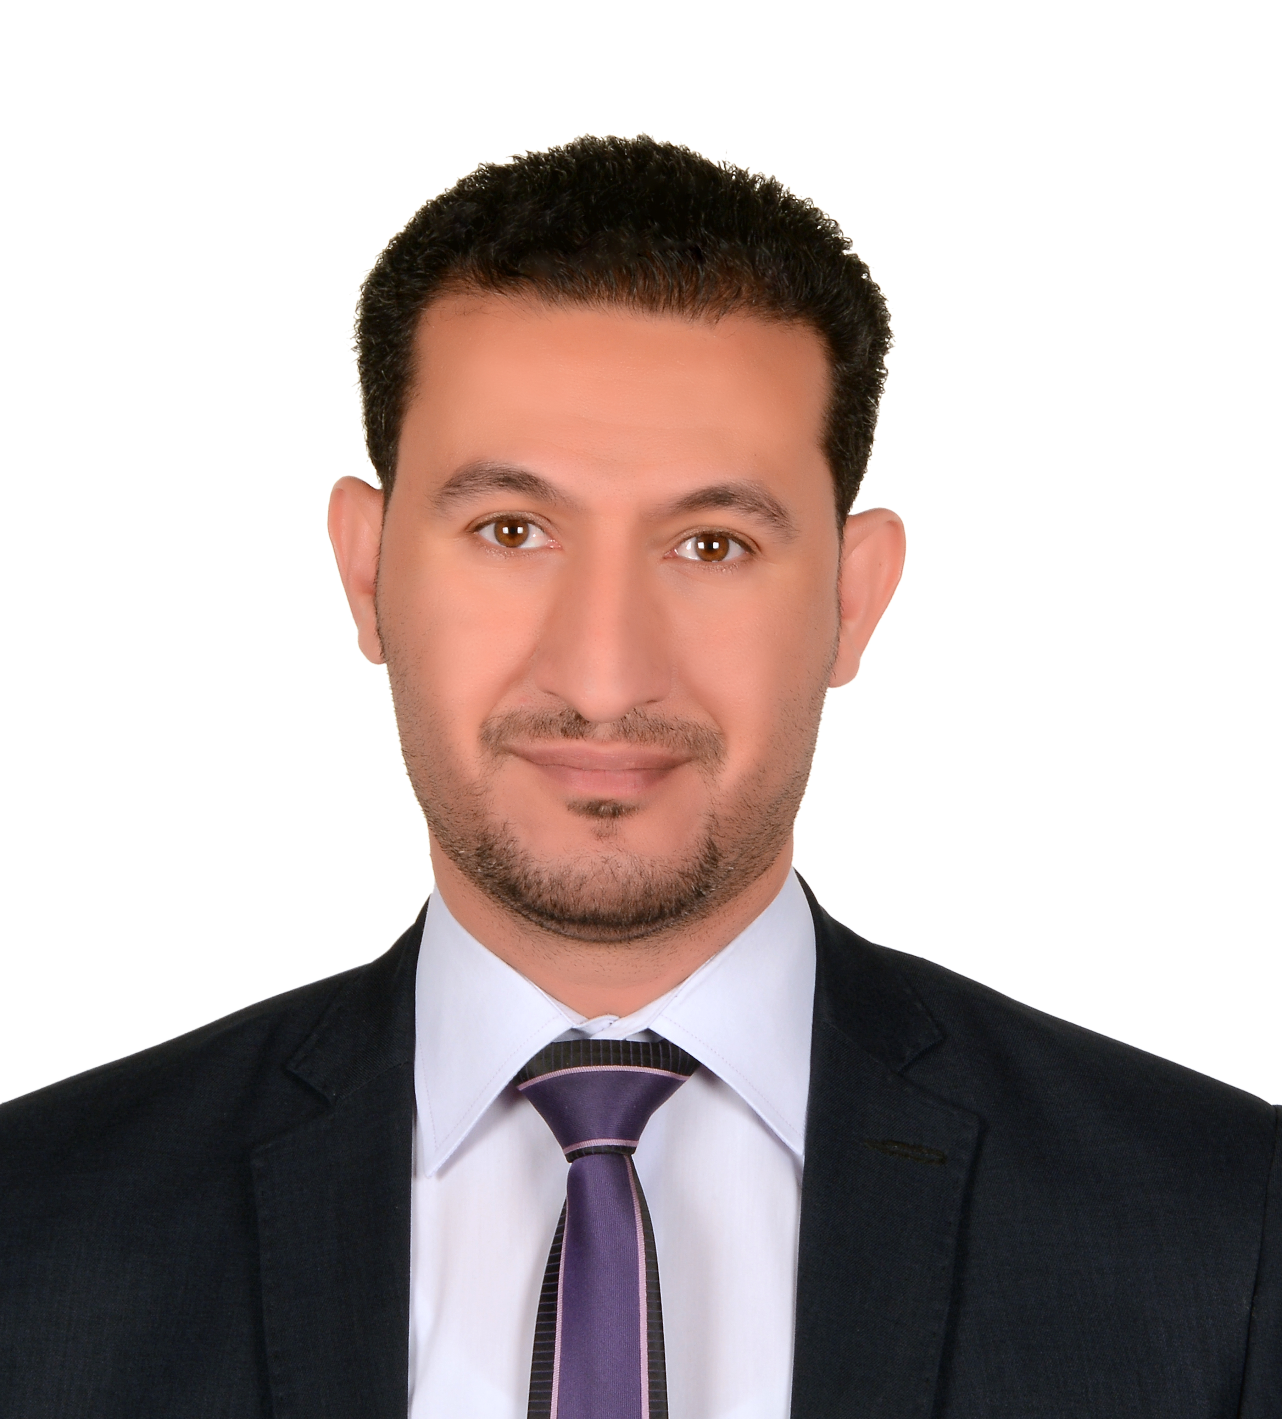
Ashraf
Ashraf.330987@2freemail.com

Roads & Infrastructures design Manger

PERSONAL INFORMATION

• Place of Birth : Cairo Egypt
• Nationality : Egyptian
• Marital Status : Married

EDUCATION

• Degree : B.Sc. in Civil Engineering (2001)
• From : Faculty of Engineering – Ain Shams University
• Graduation Project Grade : Excellent

• Additional Courses : (Civil 3D2011-MX road–Land desktop 2004,2005-AutoCAD2004, 2007,2011 – Storm Cad-Sewer
Cad-Water CAD- Primavera3-Microsoft-Excel),PMP

Designation & Approvals

- Head of Road &Infrastructures Design Dep. in Al Torath International consultants

- Approved Design Engineer from Abu Dhabi Municipality
- Approved Assistant Resident Engineer from Abu Dhabi Municipality
- Approved as Liaison Engineer with D.O.T
- Approved as Project Design Manager from Western Region Municipality

COMPUTER SKILLS
• AutoCAD 2004,2007,2011
• Civil 3D 2011-2014
• MX road program
• Land desktop 2004 -2005
• Storm Cad
• Sewer Cad
• Water CAD
• Primavera 3
• Microsoft Word
• Microsoft Excel
• Internet Basics and Advanced Skills

LANGUAGE SKILLS

• Arabic : Mother Tongue
• English : Good (Written / Spoken)

WORK EXPERIENCE

Currently Position: working as Roads & Infrastructures design Manger
−15 years’ experience in road design as follows:

• July 2008 till now : Altorath Engineering consultants U.A.E.
Job : Design Engineer , Head of Road Design unit , Head of Road &Infrastructures Design Dep. (Roads & infra structures )

• March 2006 June2008 : Aldahab Group. Cairo Egypt
Job : Design Engineer (Roads & infra structures )

• May 2004 till march 2006 : Modern Construction Co. Cairo Egypt

Job : Design Engineer (Roads & infra structures )
• April 2003 till May 2004 : Tower construction office Cairo Egypt
Job : Design Engineer (Roads & infra structures )

• January 2002 till March 2003 : Working During the Military services as Road Engineer (Design & supervision for several projects)
Job : Road Engineer (Roads & infra structures )

• July 2001 till January 2002 : E.F.A.Co. Cairo Egypt

- Work as road inspector (Trainee) for one year during the study in the college in the period between (1996and2001) in Arab Contractors company in Cairo Egypt

PROJECTS IN UAE

- AL FUJIRAH INTERNAL ROADS : Design Engineer (Roads & infrastructures )
DESCRIPTION: 30 Km of internal roads in Al Fujairah (participate in design)
Client: Abu Dhabi Municipality

- RAS AL KHAIMA INTERNAL ROADS STAGE 2 : Design Engineer
(Roads & infrastructures)
DESCRIPTION: 70 Km of internal roads in Ras Al Khaima (participate in design)
Client: Abu Dhabi Municipality

- CONTRACT 228 : Design Engineer
(Roads & infrastructures)
DESCRIPTION: internal roads maintenance in Mussafah (participate in design)
Client: Abu Dhabi Municipality

- GASCO HABSHAN PROJECT : Design Engineer
(Roads & infrastructures)
DESCRIPTION: 40 Km of internal roads in Habshan (Full Design)
Design includes road layouts, profiles, and cross-sections
Grading layouts, setting out, details for junctions (including roundabouts, marking &signs, quantities………) Client: Gasco

- BROUGE 1&2 : Design Engineer (Roads & infrastructures)
DESCRIPTION: 60 Km of internal roads in Ruwais (Full design)
Design includes road layouts, profiles, cross-sections
Grading layouts, setting out, details for junctions (including roundabouts, marking &signs, quantities ………)
Client: Gasco

- ADNOC DISTRIBUTION PROJECT 1,2&3 : Design Engineer (Roads &
Infrastructures)
DESCRIPTION: 52 filling stations entry & exist on various roads (Full design)
(Including Municipality& D.O.T approvals)
Design includes road layouts, profiles, cross-sections Grading layouts setting out, details, marking &signs, quantities ………)

Client: ADNOC DISTRIBUTION

- WESTERN REGION MUNCIPALITY SALUGHTR HOUSE AREAS 1,2&3 :
Design Engineer (Roads &Infrastructures)
DESCRIPTION: 60 Km of internal roads in western region (Full design) according to The UPC manual & WESTERN REGION MUNCIPALITY requirements
Design includes road layouts, profiles, cross-sections
Grading layouts, setting out, details for junctions (including roundabouts, marking &signs, quantities ………)
Client: WESTERN REGION MUNCIPALITY

- AL HAMRA PROJECT Stages 1,2,3,4 : Design Engineer (Roads &Infrastructures)
DESCRIPTION: 100 Km of internal roads in HAMRA (Full design)
Client: HAMRA COMPANY

- SEA PALACE PROJECT : Design Engineer (Roads &Infrastructures)
DESCRIPTION: internal roads of Sea Palace (Full design)

- POLIC H.Q. : Design Engineer (Roads &Infrastructures)
DESCRIPTION: internal roads of the new police H.Q. (Full design)
According to The UPC manual & POLICE DEP. requirements
Design includes road layouts, profiles, cross-sections
Grading layouts, setting out, details for junctions (including roundabouts, marking &signs, quantities ………)

Client: Abu Dhabi Police

- 11-AL FAYA 1,2,3 PROJECT : Construction of road network for three Al Faya
Site for fast Labour residential cities project

DESCRIPTION: internal roads of the 3 new labour cities. (Full design)
Client: Higher Corporation For Specialized Economic Zones Head

- ETESALAT PROJECT : Construction of road network for Etesalat project
According to The UPC manual & Etesalat requirements
Design includes road layouts, profiles, and cross-sections
Grading layouts, setting out, details for junctions (including roundabouts, marking &signs, quantities ………)

DESCRIPTION: internal roads of the project. (Full design)
According to The UPC manual & POLICE DEP. requirements

Client: Etesalat

- GASCO ASAP : Construction of road network for ASAP project

DESCRIPTION: internal roads of the project. (Full design)
Client: Gasco

- P.G. CITY : Construction of road network for P.G. CITY
According to The Client requirements
DESCRIPTION: Design includes road layouts, profiles, and cross-sections
Grading layouts, setting out, details for junctions (including roundabouts, marking &signs, quantities ………)

- Ajman Housing Project : Design of road network for Ajman Municipality
According to The Client requirements
DESCRIPTION: Design includes road layouts, profiles, and cross-sections
Grading layouts, setting out, details for junctions (including roundabouts, marking &signs, quantities ………)

Client: Ajman Municipality

- Consultancy services for design & supervision for road and traffic safety improvement in Liwa ,Al Maraf and Delma Island : Design of road network for Western region Municipality

DESCRIPTION: Design Manger for all roads & street lighting works includes design review and obtaining approval from UPC,D.O.T&all concerned authorities

Client: Western Region Municipality

- Consultancy services for design & supervision for road and traffic safety improvement in Ghayathi City: Design of road network for Western region Municipality

DESCRIPTION: Design Manger for all roads & street lighting works includes design review and and obtaining approval from UPC,D.O.T&all concerned authorities

Client: Western Region Municipality

- PROVISION OF DESIGN SERVICES FOR INFRASTRUCTURE FACILITIES \ EAST & SOUTH SECTORS, GHYATHI for Western region Municipality

DESCRIPTION: Design Manger for all Roads and utilities design works includes design review obtaining approval from UPC,D.O.T&all concerned authorities

Client: Western Region Municipality

- PROVISION OF DESIGN SERVICES FOR INFRASTRUCTURE FACILITIES \ Al Falah -FA05 Abu Dhabi Municipality

DESCRIPTION: Design Manger for all Roads and utilities design works includes design review obtaining approval from UPC,D.O.T&all concerned authorities

Client: Western Region Municipality

- Roads & Infrastructures in Mohamed Bin Zayed Zone D&G
DESCRIPTION: Design Manger for all Roads and utilities design works includes design review obtaining approval from UPC,D.O.T&all concerned authorities
Client: Musanada/ Abu Dhabi Municipality

OBJECTIVE

A promising talent in all what’s concerned with Civil Engineering, and would like to apply for a Job that makes the best use of the previously mentioned skills and talents.

PERSONAL SKILLS

- Communication and technical English language
- Team leader and believe in team work
- Ongoing training and self practice

