Curriculum vitae
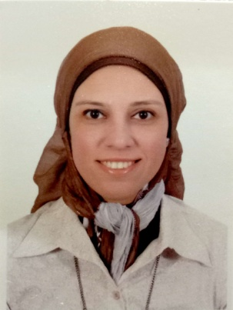
Hanan.331085@2freemail.com

Personal data
Gender: Female Date of Birth : July 19, 1980 Nationality : Egyptian MaritalStatus : Single
Objective
Aiming to obtain a job that allows me to use my qualifications and skills related to my study and my experience in the market to improve and achieve the goals of the company
Strength
- Good communication skills and fast learner of new technologies
- Self-motivated
- Ability to work in a group or individually according to job requirements
- Hard worker and can work under pressure consistently
Work Experience
Employer :
Department : Financial Decision Support – Investment (from January 2016 till date).
Job title : Financial Analyst
Job description and responsibilities
- Prepare Feasibility study and Financial Analysis for all incoming projects and promos offered to the company.
- Analyze financial data by collecting, monitoring and creating financial models for decision support.
- Follow up the financial status for all the companies which Telecom Egypt investing on.
- Prepare Quarterly Financial presentation reports showing the performance of the companies which Telecom Egypt investing on it.
- Identifies financial status by comparing and analyzing actual result with plans and forecasts.
- Maintains database by entering, verifying and backing up data.
- Protect operations by keeping financial information confidential.

Department: Prepaid Cards Sales department (from March 2010 till December 2015)
Job title : Head of Analysis and monitoring of sales and inventory
Job description and responsibilities :
- Provide general sales reporting and analysis that assists in monitoring sales performance.
- Provide data and analytical support for presentations and business reviews.
- Store data analysis, store movement, household purchase data, and consumer capabilities.
- Assists in the identification and development of business opportunities through analysis and interpretation of consumer, customer and market data.
- Forecasting to facilitate accurate production planning.
- Attend sales calls with Sales Team on an as needed basis
- Evaluates the effectiveness of promotional efforts in the market using available data sources.
Department : Phone boutique (fromDecember 2006 till March 2010)
Job title : Customer Care
Job description and responsibilities
- Generate sales leads.
- Identify and assess customers’ needs to achieve satisfaction.
- Build sustainable relationships of trust through open and interactive communication.
- Provide accurate, valid and complete information by using the right methods/tools.
- Meet personal/customer service team sales targets and call handling quotas.
- Handle complaints, provide appropriate solutions and alternatives within the time limits; follow up to ensure resolution.
- Keep records of customer interactions, process customer accounts and file documents.
- Follow communication procedures, guidelines and policies.
- Take the extra mile to engage customers.
- Collecting company’s bills every month.

Academic Qualification
- Bachelor of Science in Accounting Science (English Dept.)
Date of Graduation : May 2003
University : M.T.I University (modern university for technology and information)
University Grade : Excellent 93.6%
Subject of Graduation Project : International development of the Islamic Banks
- Higher Diploma in Business Management
Date of Graduation : May 2011
University : Cairo University, Egypt
University Grade : very good 86%
- CMA (Certified Management Accountant)
Institution : Talent Development www.td-me.com
Part : 2
Duration : In Progress
- Additional Courses
- YAT processional diploma of accounting since 2004
- Customer care course at LDP unit in telecom Egypt
- I did an English course from American university

Languages
- Arabic : Mother tongue
- English : Proficient

Computer skills
- Proficient with Microsoft Office Works Suite 2007 to include Access, Excel, Outlook Express, Power Point and Word

Summer training
- Dubai port authority (UAE), trained in human recourses and purchasing department since 2000.
- Petrobel petroleum company (EGYPT), trained in local disbursement department since 2002.

