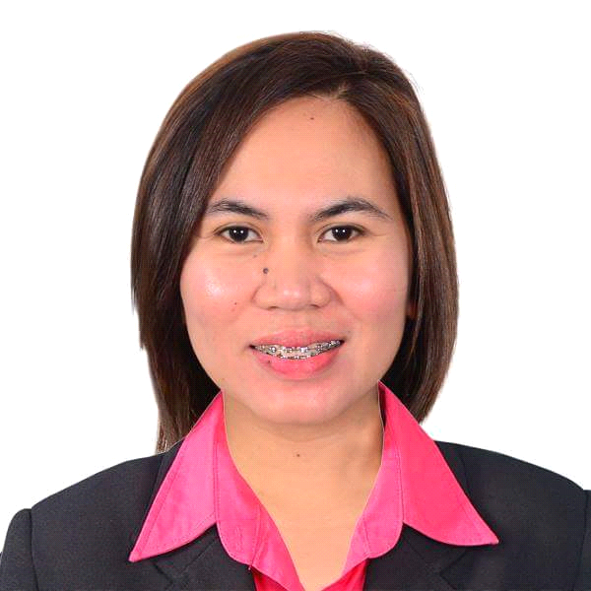
Sharon
Sharon.331112@2freemail.com
Tourist Visa (January-March 2017)
Address: Deira, Dubai UAE

To build a career in an environment that will give me an opportunity to improve my knowledge and enhance my skills of the art and technology. Be a part of a team that excels and work towards the growth of the organization and gives me a personal satisfaction.

SKILLS & INTEREST
• English literate and writing skills
• Mastery of Microsoft Office programs. Fast learner of computer software and system.
• Willing to try new things and interested in improving efficiency on assigned tasks.
• Produce work that is orderly and attractive. Ensure tasks are completed correctly and on time.
• Speaking Filipino, English and basic Mandarin.

EDUCATIONAL BACKGROUND

Short Course: St. Augustine School of Nursing
2008-2009
Professional Caregiver

College Education: Wesleyan University- Philippines
1996- 2000
Bachelor of Science in Computer Science

High School Education: Granary CO-Educational Institution
1992-1996

Elementary: Granary CO-Educational Institution
1986-1992

WORK EXPERIENCES

1. Receptionist/Secretary/Accounts:
2014-2016
Deira Gold Souk Dubai, UAE

- Catering ingoing and outgoing calls.
- Drafting correspondent letters and emails.
- Relaying phone call messages.
- Processing bills/invoices via Ornate Software.
- Managing all administrative and clerical works.
- Handling company accounts, petty cash,cheques and banks transaction.
- Responsible for assisting clients and visitors inquiries.

2. Factory Worker:
Silitech Corporation
2011-2013
Taipei, Taiwan

- Quality Control
- Machine operator

3. Administrative Staff:
Metrocity Corporation
2005-2011
Rizal, Nueva Ecija Philippines

- Control all the documents and filing.
- Sending letter and reminding clients before their dues.
- Receiving phone calls & relaying messages.
- Responsible for the office equipments and supplies.
- Performing all administrative works.

I hereby certify that the information above is true and correct.

