Name : Radha P
E-mail : radha.331145@2freemail.com
Nationality : Indian

Dear Recruiter Manager
I wish to introduce myself as an enthusiastic and articulate individual with demonstrated working experience in the field of Customer Care & Receptionists Service. Strong interpersonal skills ensuring the ability to work in a highly diverse environment in which respectful and effective communication skills are integral.
With this sort of social and professional background, I sincerely believe that I will fit into your organization. Should you require further details I will be happy to provide the same in person.

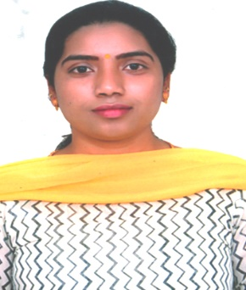
Name : Radha P
E-mail : radha.331145@2freemail.com
Nationality : Indian

Summary of Skills & Strength

A complete team worker with utmost integrity who is desirable to lead the team as per the demand of situation, who believes to do the right thing at right time. A very good team player, flexible, innovative, tactful, loyal, sincere & a very hard worker.

Special Achievements

Reorganized the reception area which increased overall efficiency by 30%

Implemented customer care strategies that have led to a 50% reduction in complaints

Experiences:

Mahindra Holidays and Resorts India Ltd- Bangalore March 2008 – Nov 2016
Front Office Cum Customer Care Executive
- Greet visitors and employees courteously and cater for their special requests, needs and complaints.
- Answer and forward phone calls to appropriate individuals and department’s
- Schedule customer bookings and guide them about available rooms and resorts
- Write letters and email using proper spelling, grammar, and punctuation
- Prepare incoming and outgoing mail and packages
- Oversee maintenance of the reception and waiting area
- Coordinate customer payments and billing
- Handle cash transactions with customers
- Issue receipts, refunds change
- Buy necessary supplies, stationary,snacks and refreshments
- Maintain cleanliness of reception area
- Work independently and collaboratively on assigned tasks

DSA Of ICICI Bank- Bangalore Aug 2007 to Jan 2008

Receptionist
- Acknowledged and greeted customers upon entering the premises
- Register customers and visitors on sign in sheet
- Scheduled appointments on phone and maintained appointment book
- Coordinated with departments for appointments availability
- Quickly responded to customer questions and concerns
- Provided information regarding facility and payment options
- Answered telephone and forwarded calls to concerned departments
- Handled cashiering tasks
- Maintained a clean and sanitized waiting area

Page Point Services – Call Centre Feb 2007 to July 2007

Customer Care Executive
- Provides customer support and handles the queries of Customer’s
- Follow-up and track on customer enquiries
- Maintains record of all enquiries & related details in Computer Systems
- Provides all Back-office support tasks like sending and receiving mails
- Resolves product or service problems by clarifying the customer's complaint; determining the cause of the problem; selecting and explaining the best solution to solve the problem; expediting correction or adjustment; following up to ensure resolution.
Educational Qualifications:

B.A. English

Languages Skills:
Tami, English, Kannada, Hindi
Computer Skills:
- MS Office (Word, Excel, PowerPoint, Vlookup)
- E- Mail (Microsoft Outlook) / Internet

