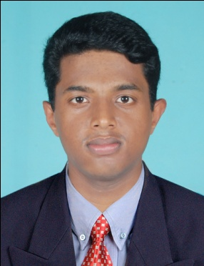

TIJU
TIJU.331150@2freemail.com

OBJECTIVE
Intended to build a career with leading organization with committed & dedicated people, which will help me to explore myself and realize my potential.

Deliverables
Masters Degree in Business Administration (Finance-HR) from Caarmel Engineering College Perunadu-India-2013
- Doing projects on the topic Financial Statement Analysis
- Worked on the firms like Duroflex and Midas for doing projects and organizational study
- A dynamic & hardworking individual determined to carve a niche in the Financial Sector.
- Equipped with the knowledge of capital market, security analysis and management of financial services and accounting.
- Fast learner with high energy and drive to exceed expectations coupled with good comprehension of financial management.
- Team player with an ability to grasp new things quickly.
Project Management:
- Excellent knowledge in Financial Statement Accounts, Time management, Security Analysis and Risk Management
- Sound Knowledge in Human Resource Management and planning
Training Skills
Have been Training in Project Planning Management, Risk Management, Time Management, Cash and inventory Management. Market analysis and security analysis.
Academics

year | course | School/College | Board/  university
2011-2013 | MBA | BC Caarmel | M G University
2008-2011 | B.com | BAM College thuruthikad | M G University
2006-2008 | Plus 2 | C.M.SHSS,Mallapally | Board of HSE
2005-2006 | SSLC | St George H S kottangal | Board of public examination

OTHER PROFESSIONAL SKILLS
Computer Skill –
Operating Platforms: windows 8, windows 7, XP
- Tally ERP.9,
- Microsoft Office 2013 – Word, Excel, power point
General Skill – Having good knowledge of computer and good at accounting.
WORK EXPERIENCE
Working as an accountant in palakaddan foods (food manuf.unit) in 2011 march-2012 April (1 yr)
Working as an internal auditor in Kerala traders (trading concern) in 201
2 April 20-2014 July 6 (2 yrs)
Working as Sr.Accountant in Southern Trading Concern for 2014 July 7-2016 Dec 15 (INDIA) (2yrs exp)

SOFT SKILLS
- Highly Adaptive
- Honest & Sincere
- Good Team player
- Optimistic
- LANGUAGE KNOWN

- English
- Hindi
- Tamil
- Malayalam

HONOUR & ACTIVITIES

- Participation in NSS.
- Active participation in various clubs in college.
- Paper presentation on “financial inclusion” in National seminar.
HOBBIES AND INTERESTS
- Visiting new places.
- Reading
- Driving
- Playing Badminton

DECLARATION
I hereby declare that all above statements are correct and complete in my knowledge and belief.

