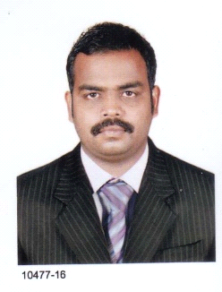
KANNAN
KANNAN.331168@2freemail.com

Objective

To complete my Internship as per course curriculum by working in an environment that will enhance my knowledge for framing my career, and to achieve pivotal position where I can maximize my management and programming skills to utilize them for the growth of the organization.

Profile

A Results driven professional who has over Three years experience with products that are considered Technical and complex , I am able to aggressively drive sales growth and Profits by Developing a friendly , well trained sales team who are always highly visible to customers and responsive to their needs, I have a hands on style of managment , and one of my key strength is the ability to generate business insights from diverse data sources.
Key Skills

- Landing pages
- Banner advertisements
- Magazine layouts
- Digital photography
- Advertising campaigns
- Delegating responsibility
- Languages Known : English, Tamil, Malayalam , Arabi

Professional Experience

Qawafil Al – Atta Trading LLC June 2013 to October 2016
Photoshop Designer ( Sports Items Trading)
Muscut - Oman

Responsible for creating, developing and producing design work for use in a variety of media platforms.
Duties
- Creating edgy and fashionable designs.
- Overseeing the visual expression of a client’s brand.
- Working in collaboration with photographers, copywriters, printers and other designers.
- Contributing designs and artwork to projects.
- Meeting with clients to discuss their business objectives and requirements
- Ensuring strict adherence to quality control methods.
Education and Training

Tamizhen College of Engineering & Technology (Anna University) 2009-2012
B.E (Computer Science and Engineering)
Nagarkovil , Tamilnadu , India

- 7.5 GPA
- Coursework in Java.

PROJECT : DETECTION AND TRACEBACK METHOD PROTOCALS (DTRAB)
Duration : 120Days.
Team Size : 2
Environment : JAVA

Description : The protocols which are used to provide the secure the
communication are often target to the trace-back methods.

Sree Krishna Polytechnic 2006-2008
Diplomo (Computer Science and Engineering)
Nagarkovil , Tamilnadu , India

- 7.0 GPA

Professional Affiliations

- CHENNAI GOOD LIFE CENTRE - ORPHANAGE, Member

Declaration

I do hereby declare that the information furnished above is true to the best of my knowledge and belief.

