MUHAMMAD

APPLY FOR JOB IN H-R

MUHAMMAD
MUHAMMAD.331186@2freemail.com
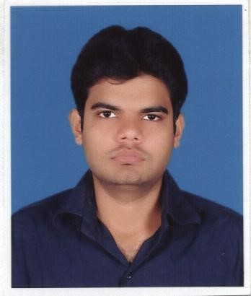

CAREER OBJECTIVE

To seek challenges as a business administrator in a diverse back ground where expertise in business skills could be utilized and advanced. To be able to work on own initiative or as part of a team. Job perfection and cooperation is my prime motto.
Career Profile:

.
education

Degree | Institute | Year
MPA  (Master In Public Administration)  (In HRM) | UNIERSITY OF KARACHI | COMPLETED  November-2016
BBA  (Bachelor In Business Administration)  (In HRM) | FEDERAL URDU UNIVERSITY | 2014
INTER (PRE ENG) | SUPERIOR SCIENCE COLLEGE | 2009
MATRIC | NOMAN PUBLIC SCHOOL | 2007

CERTIFICATE COURSE
ENGLISH LANGUAGE | KARACHI UNIVERSITY | 2011

PROJECT

I have done Eight month project on Documentation Management in Human Resource Department at TCS (pvt) ltd

INTERNSHIP

I have done internship in PIA.

EXPERIENCE

I have an experience for more than one years as a chemistry and mathematics teacher of class 9 and 10.

Relevant Skills & Interests

- Work well with others and I make a good team leader.

- Team player with a positive attitude and result-oriented.

- Effective problem solving & updating with New Technologies.

- Application Design, Development, Information System and Management Analysis.

- Willing to Travel.

Strengths

- Positive thinker with high energy level, career-oriented, quick learner with positive can-do attitude. Ability to work efficiently & effectively as part of a team.

