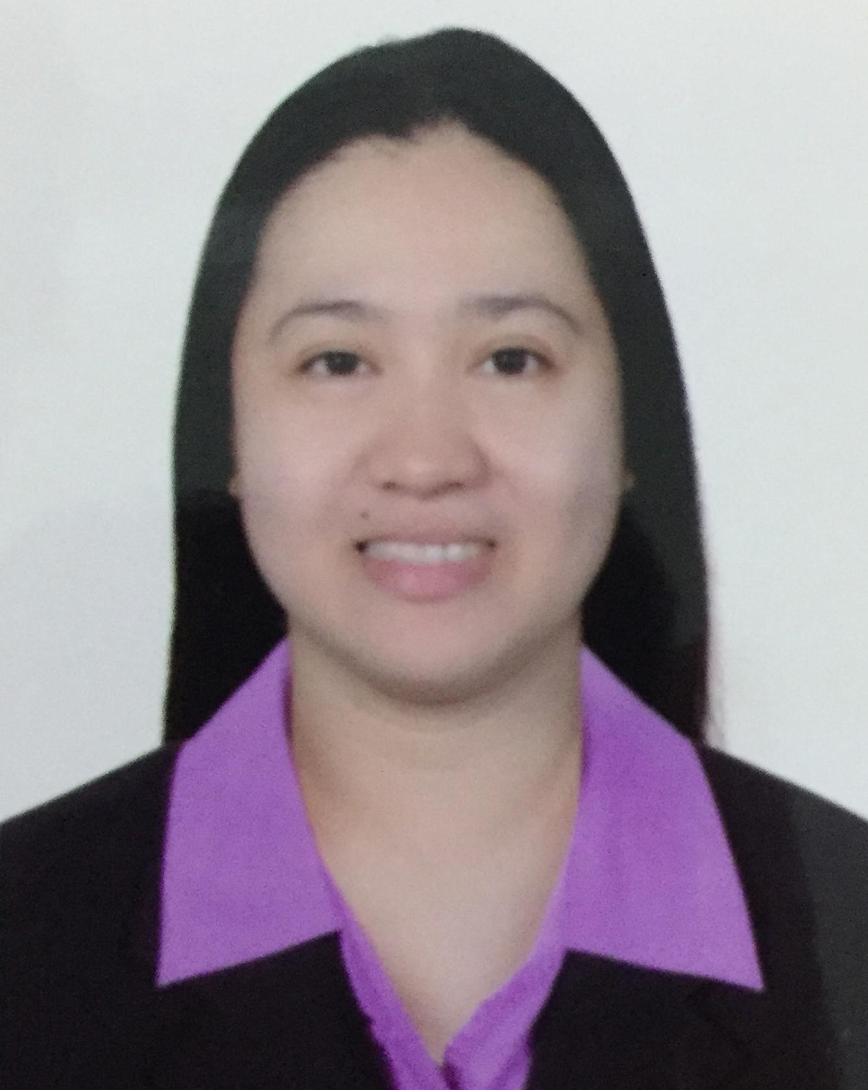
ROSEBELLE
ROSEBELLE.331190@2freemail.com

Objective:
Willing to work for a reputed organization to deliver my service up to best of my capabilities.

Experience:
UNION COOPERATIVE SOCIETY
Cashier/Sales Associate
Al towar , Al Qusais – Dubai United Arab Emirates
March 03,2008- August 31,2016
- Duties and Responsiblities
    - Handle POS/Cashiering process.
    - Deposit money in the Bank.
    - Ensure all prices are correct.
    - Sending and Receiving necessary documents.
    - Oversee daily accounting and preparing reports for the
daily sales
    - Maintain and aware of all promotions.
    - Train new cashier
    - Customer Service Rep
    - Emirates Islamic with tamayaz credit card
    - Handle different cards/membership cards

GLOBE TELECOM INC
Indoor Sales Associate/Account Activator
Pasig Philippines
August ,2004- February 2008
- Duties and Responsibilities
    - Encode 50 to 80 postpaid line application per day
    - Review the background application
    - Filling the application form
    - Reactivate the Account of the customer
    - Sales Representative regarding post paidline
    - Email the different branches regarding autoloadmax
    - Activate the autoloadmax by request of different branches
    - Encode the SME corporate Account

EDUCATIONAL BACKGROUND

TERTIARY:
Bachelor of Science and Business Administration
Major and Management (Graduate)4 years
Pamantasan Lunsod ng Pasay (1999-2003)

PERSONAL DATA:
Age: 34
Date of Birth: February 07,1982
Civil Status: Married
Religion: Roman Catholic
Language: English, Tagalog

TRAINING/CERTIFICATE
Customer Service
Etisalat Academy
May 3, 2016

SKILLS
Computer literate, Word, Customer Service, Data Entry

