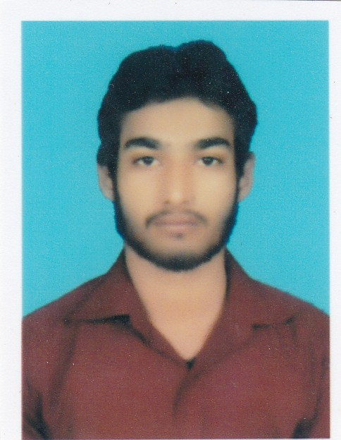
Yasir
Yasir.331213@2freemail.com

Objective
A highly astute and responsible individual who has the aptitude to succeed in an extremely competitive environment, a quick learner with strong work ethic who is also team spirited, self-motivated, resourceful, reliable and very committed with ability to achieve meritorious standards of work. Can Shoulder the assigned responsibilities diligently.

Working Experience
Western Union by Ravi Exchange (Pvt.) Ltd.
Worked as Branch in charge and Teller/cashier
July 2015 to October 2016
Responsibilities
- Installing and configuring computer systems, diagnosing, analyzing and rectifying
Hardware and Software faults
- Receiving and paying cash for the company and maintaining the record for it
- Keeping the record of negotiable instruments involved in a financial
Institution’s various transactions
- Dealing in foreign TT # DD.
- Handling the foreign currency
- Entertaining the Western Union payments

New Multan Stockiest
Tianshi international Pakistan co. (pvt) ltd
Worked as an Administrator
July 2014 to June 2015.
Responsibilities:-
- Updating Basic Accounts and Book Keeping
- Sale record entry through Web Based Online Software
- New Joining Wintry through Web Based Online Software
- Supervising Sales, Purchase and Marketing
- Customer Relation
- Invoice entries and cross checking
- Preparing and analyzing financial statements
- Helped in preparing tax returns.

Academic Qualification
- BS-IT 2015 University of Education Lahore
- Faculty of Science 2011 Rise College of Science
- Secondary School Certificate 2009 Laureates Public High School

Core Competencies
- Adaptability.
- Self-Starter and hardworking
- Focus on Continuous Improvement
- Ability to handle the stress situation
- Efficient Supervisor

Other Skills
- Internet Browsing
- Computer Literate
- Php, Asp.net C#
- Networking
- CCNA
- DBMS

Reference
- Will be furnished on demand

