Maricris
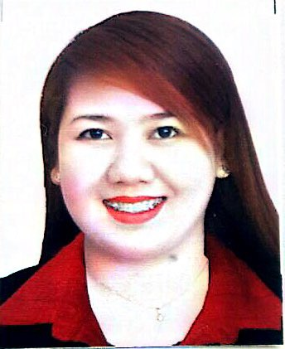

Maricris.331217@2freemail.com

OBJECTIVE

I am currently looking for a full time position in an environment that offers a greater challenge, increased benefits for my family, and the opportunity to help the company advance efficiently and productively

WORK EXPERIENCE

Cashier / Vault Custodian/ Western Union Agent – Feb 2013 – May 2016
SINAG Pawnshop – JMS management service link corporation Ibayo Marilao Bulacab Philippines

Responsibilities:

- Greet customers as they arrive at the store and guide them regarding different sections
- Monitoring customer account details for non payments, delayed payments and other irregularities
- Prepares reports on the list of expired pledge articles in a timely manner.
- Responsible for handling and safeguarding of cash and pledge items.
- Making sure that the vault premises are restricted to unauthorized personnel.
- Cash Disbursement to designated payee or its authorized representative
- Preparing cash teller remittances and requisitions slip.
- Handling the receipt and release of cash for daily transactions.
- Performs such other functions as may be required from time to time
- Responsible for the preparation of the pawn tickets. Fills out the pawn tickets (complete) in every transaction either manually or through computer.
- Checks redeemed pawned tickets before release and issues corresponding official receipts of redeemed pawn tickets.
- Checks monthly summary of loans extended and loans paid.
- Receives office messages and communications.
- Doing minor appraisal and item pawning, Act as petty cash custodian.

Cashier - Jul 2012 – Dec 2012
Landmark Department store – Quezon City Philippines

Responsibilities:

- Responsible for doing cash and visa transactions
- Receive payments for product sold- whether by cash, check, vouchers, credit cards, or automatic debits
- Issue receipts to customers for products bought; make necessary refunds, credits, or change to customers
- Provide assistance to customers by making available information on products, and their benefits
- Resolve customer complaints
- Ensure safe keeping of periodic balance sheets of numbers of transactions and respective amounts
- Keep records of transaction totals
- Compute every transaction
- Calculate payments in total received during a specific period of time and compare with total product sale

Cashier - Jan 2012 – Feb 2012
The Faceshop - Trinoma Mall Quezon City Philippines

Responsibilities:

- Responsible for doing cash and visa transactions.
- Greets and assist customers in a very welcoming manner.
- Provide customers the information about the products and giving the advise before the purchase to help them decide.
- Count money and audit money drawers.
- Resolve customer complaints

Cashier / Sales representative –Jul 2011 – Dec 2011
Sportzone SM shopping centre Manila Souther Associates Inc. Brgy. Ibayo Marilao Bulacan Philippines

Responsibilities:

- Greet customers as they arrive at the store and guide them regarding different sections
- Count money and audit money drawers.
- Keep accurate records of monetary exchanges, authorization forms, and transaction reconciliations.
- Maintain cage security according to rules.
- Issue receipts, refunds, credits, or change due to customers.
- Resolve customer complaints
- Answer customers' questions, and provide information on procedures or policies
- Sell tickets and collect fees from customers.
- Operate, drive, or explain the use of mechanical riding devices or other automatic equipment in amusement parks, carnivals, or recreation areas
- Fasten safety devices for patrons, or provide them with directions for fastening devices

Cashier / Sales representative – Nov. 2010 – Apr 2011

SM Department Store Manila Southern Associates Inc. – Brgy. Ibayo Marilao Bulacan Philippines

Responsibilities:

- Responsible for welcoming customers to the store, talking to them, helping them and generally making their shopping trip memorable
- supporting the store in meeting its sales targets by recommending products to customer and making sure the shelves are stocked with the things they want to buy.
- Ensuring the correct display, cleanliness and tidiness of merchandise and promotions.
- Recommending additional products to customers

EDUCATION

MOTHER OF DIVINE ASSISTANCE COLLEGES INC. (PHI)
TERTIARY – 2006 – 2010
BACHELOR OF SCIENCE IN COMPUTER SCIENCE

ASSEMBLY WOMAN FELICITA G. BERNARDINO MEMORIAL TRADE SCHOOL (PHI)
SECONDARY – 2002 -2006

SALUYSOY CENTRAL SCHOOL (PHI) - PRIMARY SCHOOL 1996 - 2002

PERSONAL INFORMATION

BIRTHDAY : 25 DEC 1990
AGE : 26 y/o
CIVIL STATUS : SINGLE
HEIGHT : 5’4”
WEIGHT : 54 kg
VISA STATUS : TOURIST VISA

REFERENCES

References are available on request.

