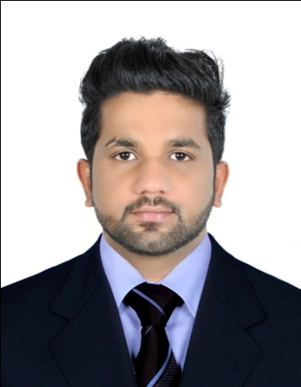
Curriculum Vitae

SALEEM
SALEEM.331228@2freemail.com

OBJECTIVES
To work for an organization which will help in value addition and serve as a spring board to move ahead in my career by providing me interesting career opportunities and harness the best of my caliber.

WORK EXPERIENCE

CARREFOUR HYPER MARKET (MAJID AL FUTTAIM RETAIL)

Presently working experience as a Accounting Cashier at Carrefour (MAJID AL FUTTAIM GROUP)Deira city center,Dubai

Position : Cashier clerk (follow up clerk)
Period : From march 2014
Job discription :
- To greet the customers entering into organaisation.
- To handling all the cash transaction of an organaisation.
- To recieve payment by cash,forign currency,credit card,beam payment and other vouchers etc.
- To checking daily cash accounts.
- To guiding and solving queries of customers.
- To providing training and assistance to new joined cashier.
- To daily report of transaction.
- To make inventory of store in accounting periods.

AVENUE Tiles & Bath Studio, Kerala,kasaragod ,india

Position : Assistant Accountant
Period : Since may 2012 to 15 November 2013
Job Description :
- Maintenance of accounts.

- Working with Tally Sales, Purchase, Payment and received, JV.

- Preparation of Bank Reconciliation Statement & Internal Reconciliation.

- Journal entries and Ledger maintenance.

- Invoicing,

- Verification of quotations, Purchase orders etc..

- Handling Petty Cash, Cash & Bank Receipt, Payments, Purchase journel Entries .

- Preparation of Daily & Monthly Sales /Revenue report.

- Day to day update of Transaction, Deposit & Withdrawals with Banks, Issuing of Cheque, Money Transfer.

- Interacting with Clients and Term members in respect of clarifying their doubts.

- Preparation of Debtor’s outstanding statement & Involving in the process of collection If required

EDUCATIONAL QUALIFICATION

- Graduation in BBM at Mangalore University (2009-12).
- Plus Two in Kerala state board examination
- SSLC in Kerala state board examination

Technical Qualification

- DCFA (diploma in computerized financial accounting)
SOFTWARE LIKE: TALLY ERP, WINGS. PEATCH TREE, QUICK BOOK,MS EXCEL.

SKILLS AND STRENGTHS

- Good qualitative aptitude along with excellent grasping power and eagerness to learn.
- Proficiency in communication skill
- Self motivation and a passion to succeed.
- Able to remain calm and relaxed under pressure
- Enjoy working with figures
- Highly focused on providing customers with a good experience

AREAS OF EXPERTISE

Finance,Branch sales, cashiering, customer facing, computer literacy, doing
Repetitious work accuratel.

PROJECT WORK

- Customer Satisfaction Project in KVR Cars ( Dealers in Maruti Suzuki) ,Kasaragod ,

LANGUAGES KN0WN

English, Hindi, Malayalam, Urdu & Kannada

PERSONAL DETAILS
Date of birth : 19th May 1991
Gender : Male
Marital status : Single
Nationality : Indian
Religion : Muslim

Reference: available on request.
I hereby declare that all the statement made me in this c.v is true complete and correct to the best of my knowledge

2 years and 7 months cashiering experience
1 year and 6 month accounting experience
total 4 years experience in finance

