CURRICULUM VITAE

PRAKASH
PRAKASH.331291@2freemail.com
D.O.B. :27.10.1986
Sex : Male
Marital Status : Single
Nationality : Indian 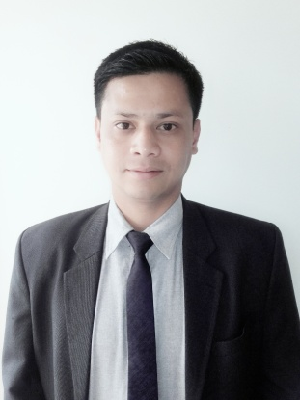

CAREER OBJECTIVES:
To secure a challenging career with dynamic, serving, progressive organization in order to utilize my potential, knowledge and personal acumen with integrity contribution in the development.

PERSONAL DETAILS:
An excellent communicator, confident in dealing with people from all walks of life. Ambitious and focused while appreciating the need to remain flexible.

Communication:
Confident telephone manner.
Good verbal and written skills.
Working as a Visiting Faculty and a Post Graduate Teacher allowed me to enhance my communication skills.

Problem Solving:
Degree course allowed me to enhance my analytical and problem solving skills.

Team Work:
During my Master Degree, I took part in a national science seminar as the MC in our institute. This involved time management, commitment and communication, and helped me to realize the value of team work.

I.T. Skills:
I have knowledge of, and am competent in using Microsoft Office, including Word, Excel and PowerPoint. Also I am familiar with the e-mail systems.
I am a confident internet user and have used the web to research many topic areas for my course.

Languages:
Comfortable in English, Hindi and Nepali (written and spoken).

EDUCATION QUALIFICATION:
Sikkim Manipal Institute of Technology, Majitar  2010-2012 | M.Sc. in Chemistry | Specialisation in Organic Chemistry | A grade(85%)
Darjeeling Govt. College, Darjeeling  2004-2008 | B.Sc. in Chemistry(Hons.) | Chemistry(Hons.),Physics, Math, English and Nepali | 48%
Sadam Sr.Sec.School,  South Sikkim  2002-2004 | XII (P.C.M)  (C.B.S.E) | Chemistry, Physics, Math, Nepali, English and Phy .Edu.(Opt.) | 60.5%
Saptashree  Gyanpeeth School,  Kalimpong  2002 | X(I.C.S.E.) | Chemistry, Physics, Math, History,Geography, Nepali and English | 60.8%

WORK EXPERIENCE:
June '12- September '12 | Torrent Pharmaceuticals,Sikkim  Worked as an Executive Trainee in the Stability Section of Quality Control Deptt.
October '12-December'12 | EIILM University,Budang, South Sikkim  Worked as a Visiting Faculty (Chemistry)for B.Tech, Bio-Tech and B.Sc. (Environment and Ecology Deptt.)
March '13-Till Date | Namthang Sr.Sec. School, South Sikkim  Working as a Post Graduate Teacher(Chemistry)

SPECIAL ACHIEVEMENTS:
Received a meritious scholarship of Rs/-10,000 from SIPCA and a gold medal for standing 1st in M.Sc(1st year) from Sikkim Manipal Institute of Technology'12.
Also bagged another gold medal from His Highness, The Honorable Governor of Sikkim for being the overall topper of the entire M.Sc. Deptt. Of SIkkim Manipal University'12.

PERSONAL INTEREST:
I am interested in learning, teaching and laboratory work, reading books and novels, like travelling with friends and also listening to music, especially soft and classical.

DECLARATION:
I would be grateful if you consider my application for a suitable post and can assure you that I can discharge my entire obligation to your utmost satisfaction and will always strive for the betterment of your firm.

