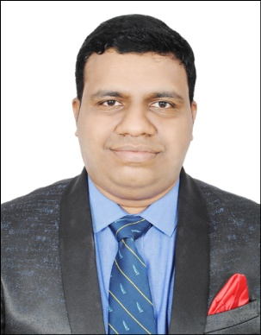
TITUS
TITUS.331292@2freemail.com

CAREER OBJECTIVE
To seek a challenging position in different industry and establish a good working relationship with the organization to achieve a successful career and fulfil the needs of the organization to their laid down targets.
EDUCATIONAL QUALIFICATION:
COLLEGE/SCHOOL | NAME OF COURSE | BOARD OF EDUCATION | PERCENTAGE | YEAR OF PASSING
ST ALOYSIUS HIGH SCHOOL | S.S.LC | KARNATAKA STATE BOARD | 46.56% | 2002
ROSARIO P.U COLLEGE | P.U.C | KARNATAKA STATE BOARD | 60.17% | 2004
SHREE GOKARNANATHESWARA COLLEGE | B.COM | MANGALORE UNIVERSITY | 48.12% | 2007
MANGALORE INSTITUTE OF FIRE AND SAFETY ENGINEERING | P.G DIPLOMA IN HEALTH SAFETY AND ENVIRONMENT | MYSORE UNIVERSITY | 85.68% | 2015

FIRST AID TRAINING :
- Have undergone First Aid Training course conducted by St John’s Ambulance Bangalore.

COMPUTER PROFICIENCY :
- Microsoft Word, Excel, PowerPoint, E-Ticketing, E-Commerce & E-Billing.
STRENGTH & ABILITY :
- Good observer and fast learner, good at human relations.
- Hard working nature
- Positive thinker, Ambitious
- Leadership quality
- Good in communication skills
- Responsible, Potential to convince people.
- Positive attitude, commitment towards work, sincere and punctual
EXPERIENCE :
- Worked for 7 years as Sales Executive in Premier Teleconnect India Pvt Ltd which deals in selling of Nokia and Microsoft handsets which is of International repute.

PERSONAL INFORMATION :
SEX : MALE
MARITAL STATUS : SINGLE
DATE OF BIRTH : 19/06/1986
NATIONALITY : INDIAN
RELIGION : ROMAN CATHOLIC
LANGUAGES KNOWN : ENGLISH, HINDI, KANNADA, TULU
MOTHER TONGUE : KONKANI

DECLARATION :
I hereby declare that all the above information provided are true and correct to the best of my knowledge.

