DHANYA
DHANYA.331295@2freemail.com
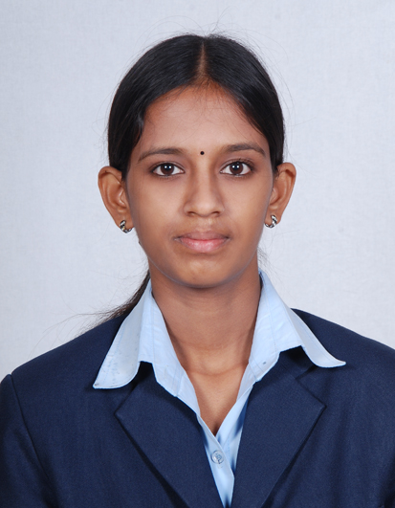

Professional summary
A committed and motivated MBA graduate with strong interpersonal skills and an ability to work under target driven, time bound situation.

Personal Traits

- Inquisitiveness to learn and grasp as much of any situation
- Quick learner and self driven
- Customer centric
- Self-Driven, sets high benchmark
- Positive Attitude and adaptable to changes
- Articulates with ease, people driven and committed to deliver results
- Leadership and Trust
- Inspires positive change, and leads by example
- Ability to prioritize tasks with high degree of flexibility with time bound action

Work Experience

Branch in charge

MANAPPURAM FINANCE LTD. THRISSUR, KERALA, INDIA

Junior Assistant : From June 2013 to August 2014
Assistant Branch Head : From August 2014 to November 2015
Branch Head : From November 2015 to December 2016

Purpose of Job:
- Handling accounts.
- Meet customers, understand their borrowing needs.
- Assess suitability as per Company Policy and process the relevant applications professionally and forward with proper recommendations for approval to the sanctioning/approving authority.
- Marketing and bringing deferent type of deposits from various customers by offering preferential competing interest rate.
- Handling cash, pledging documents and Gold Ornaments those customer avail loan against, taking responsibility to control staff and company smooth running.

Education

Masters in Business Administration (74%)

Major in Finance & Marketing 2011 - 2013
Guruvayurappan Institute of Management, Coimbatore, INDIA
Bharathiar University, Coimbatore, Tamilnadu INDIA

Bachelors in Business Administration (72%) 2008 – 2011

Finance
M P M M S N TRUST COLLEGE, SHORANUR
KERALA, INDIA

Higher Secondary Certificate Exam (72%) 2008
AISSCE, INDIA

Senior Secondary Exam (75%) 2006
Kerala State Board, INDIA

Computer skills

- Tally/ERP
- Microsoft Office Package (Excel, Word, Power Point)

Activities & Achievements

- Won first prize in Finance game in inter college management meet
- Won second prize for best management team at inter-college management meet -2012
- Participated in management meet at ‘PPG INSTITUTE OF MANAGEMENT, COIMBATORE-2012
- Coordinated BRAND WAR program in affiatus at Guruvayurappan institute of management -2012
- Coordinated Finance game in affiatus at Guruvayurappan institute of management-2013
- Won second prize for best management team at inter-college management meet -2013

Language skills
- English
- Malayalam
- Tamil
Dhanya

