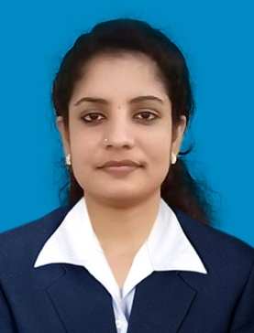
CURRICULAM VITAE
SREESHMA
SREESHMA.331314@2freemail.com
Career Objective
To be part of a professional organization and work in a dynamic and challenging environment, which offers an opportunity to grow, develop and contribute my Management and Professional skills to the growth of the organization.
Educational Qualifications

ICWAI INTERMEDIATE
INSTITUTE OF COST ACCOUNTANTS OF INDIA, KOLKATA, INDIA.

Master in Commerce (M.COM)
MADHURAI KAMARAJ UNIVERSITY, INDIA

Bachelor of Commerce (B.COM)
PAZHASSI RAJA N.S.S COLLEGE, MATTANNUR, KERALA, INDIA

PROFESSIONAL EXPERIENCE

THALASSERY MISSION HOSPITAL PVT.LTD.
ACCOUNTANT
(10.02.2013-30.11.2016)

- Prepares asset, liability, and capital account entries by compiling and analyzing account information.
- Documents financial transactions by entering account information.
- Examine statements to ensure accuracy.
- Ensure that statements and records comply with laws and regulations.
- Compute taxes owed, prepare tax returns, and ensure prompt payment.
- Ensure company accounts and tax returns are prepared and filed correctly and on time.
- Inspect account books and accounting systems to keep up to date.
- Organize and maintain financial records.
- Improve businesses efficiency where money is concerned.
- Make best-practices recommendations to management.
- Managing petty cash transactions.
- Suggest ways to reduce costs enhance revenues and improve profits.
- Preparing statutory accounts. Calculating and checking to make sure payments, amounts and records are correct.
- Summarizes current financial status by collecting information; preparing balance sheet, profit and loss statement, and other reports.
- Provide necessary arrangements to auditors during audit programme.

ACHIEVEMENTS

- Plus two with Distinction
- B-com with Distinction
- ICWAI (CMA) Inter passed in first attempt
- M-com with First Class.

Professional Training / Certification

• Computer training organized by ICWAI (Qualified with A-grade for study on information technology in information systems for auditing, Cost management, and financial accounting-programming techniques, RDBMS Concepts, ERP Packages, M.S. Office and Accounting Packages) .
• General Management and Communication Skill development program.
• Attended Professional Seminars and Conferences conducted by ICWAI.
• Working Computer knowledge with Tally.ERP9 and MS Excel, MS office.
• Attended industrial training/Modular training.

Personal statement

Have a clear, logical mind with practical approach to problem solving with an eye for details. Quick learner, I enjoy overcoming challenges.

Languages Known
English, Malayalam.

