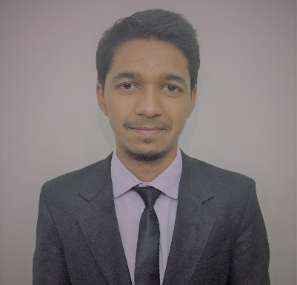
MUHAMMED
MUHAMMED.331318@2freemail.com
Objective

- Seeking challenging assignments to leverage experience and expertise with an organization of repute.
- To attain Perfection &Excellence in My work and upgrade the Knowledge & Technical skill towardsthe betterment of the organization and myself.
- To set an example for others in the organization by being a role model thus contributing to the overall success of the organization.

Educational Credentials

- B.Com from Bangalore University – 2014
(Bachelor of Commerce in Accountancy and Business Management)

Work Experience

First Advantage Global Operating Center Private Limited - Bangalore, India
Designation: Operations Analyst
FROM DATE: March 2016 to October 2016

- Pre-employment verification job.
- Delivering quality results within the SLA of client, and analysing end to end process of verifying candidate’s educational, employment and government issued id documents with maximum adherence of compliance with the confidential data provided.
- Catering the requirements of client and the country of applicant.
- Performing quality checks and logging errors to colleagues.
- Communicating updates and discussing issues with On-Shore team.
- Utilizing multiple tools and SOP’s to complete each case.

Siemens Technology and Services Private Ltd - Bangalore, India
Designation: Junior Specialist
FROM DATE: Feb-2015 TO Feb-2016

- Worked as acustomer service agent in accounts payable team as a junior specialist.
- Multi-tasking job of processing invoices for payment, handling calls & emails by ensuring good conduct with customers in the highest level of integrity.
- Addressing customer queries and providing perfect resolution.
- Delivering utmost quality, excellent and delightful customer service.
- 60 – 80 calls and 100 + emails were responded through CRM & Contact tool every day.
- Capable to manage correspondence, filing, high volume of e-mail and contact management,
Large volume of calls and client service skills.
- Work involving interacting with vendors and Co-ordinating simultaneously with other teams in releasing of payments.
- Responsible for smooth operations of both responsibilities (Customer care and Payments) by proper scheduling and planning of activities.
- Efficient knowledge of SAP.

N.A.P Computers - Bangalore, India
Designation: Sales executive
FROM DATE: Aug-2011 TO May-2014

- Worked in a retail electronic store (Part-time Job of 6 hours, for 3 years while completing my graduation)
MY DUTIES
- Managing sales of the store by inventing attractive offers.
- Handling All the Escalations calls and emails.
- Updating of sales & purchase invoices in the tool.
- Keeping all records of customer to provide them warranty on the product purchase.
- Attended all product training from different companies (installing prose’s)
- I had 2 Members under my supervision for Sales.
- Provided online service to customers.
- I have handled corporate orders.

Competency Matrix

- Team Coordination
- Accounts Payment’s
- Team & People Management
- Understanding Client’s Requirement
- Process Improvement

Personality Traits

- Highly evolved People management and Client Relationship Building skills with superlative communication & inter-personal capabilities.
- Strong leadership and motivational skills.
- Ability to handle pressure.
- Excellent written and verbal communication.
- Ability to work under any kind of environment.
- Willingness to learn, team facilitator and a hard worker.

Computer Skills

- MS Office
- E-Mail Systems
- SAP (Basic knowledge)

Personal Details

- Date of Birth › 23-August-1992
- Gender › Male
- Marital Status › Single
- Languages › English, Hindi, Urdu, Kannada
- Visa Status ›Visit Visa (Valid Until 15-Jan-2017)

Declaration

I hereby declare that above information is correct to the best of my knowledge and belief.

