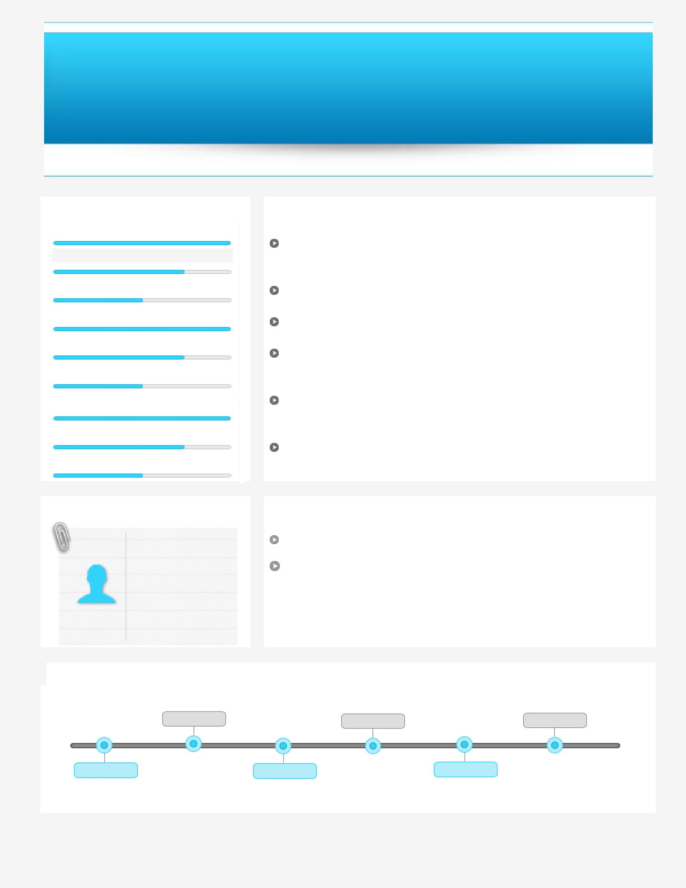
AMIT
AMIT.331371@2freemail.com

~ Senior Level Assignments ~

~ Restaurant Operations ~

Key Skills

Restaurant Operations

Customer Relationship Management P & L Management Business Development

Cost Control

Facilities Management

Performance Management

Training & Development

Team Building & Leadership

Profile Summary

Performance-driven Professional with 18 years of experience in Restaurant Operations, Profit Centre Operations, Client Management, Budgeting, Administration, Training and Team Management

Last associated with Johnny Rockets (US Burger Chain), Qatar as Restaurant Manager

Proficient in initiating & developing relationships with key decision-makers in target organizations for business development

Skilled in creating and sustaining a dynamic environment that fosters the development opportunities and motivates the high performance amongst the team members

Hands-on experience in regularly collaborating with guests to gather their feedback on the services provided and based on that planning further business strategies

An enterprising leader with skills in leading personnel towards accomplishment of common goals

Soft Skills

Team player

Communicator

Innovator

Thinker

Education

1996: MBA in Sales & Marketing from National Institute of Sales, Chandigarh.(NIS)

1995: BA in Economics, Political Science, Public Administration from DAV College, Chandigarh, Punjab University

Career Timeline

Pizza Hut, Chandigarh |  |  |  | Pentacle Hotels and |  | Wild Wing (Restaurant
 |  |  |  | Restaurants Pvt. Ltd,
 |  |  |  |  |  | Chain), Canada as
as Restaurant General |  | 2007-2010 | Chandigarh as Operations
 |  |  |  |  | 2011-2013 | Restaurant Manager | 2014-2016
Manager
 |  |  |  | Manager
 | RTC Restaurants India |  |  |  | Pizza More, |  | Johnny Rockets (US
1998-2007 |  | Pvt Ltd. (Ruby |  | 2010-2010 |  | 2013-2014
 |  |  |  |  | Chandigarh, |  | Burger Chain), Qatar as
 | Tuesday), Chandigarh
 |  |  |  | Operations Manager |  |  | Restaurant Manager
 |  | as RGM

Work Experience

Jul’14 to July’16 Qatar Restaurant Manager

Role:
- Implemented performance enhancement measures such as KPI that resulted in benefits

- Managed Daily Sales Tracker vs Budget to ensure that P & L management was in place

- Coordinated the entire restaurant operation, including front-of-house and back-of-house

- Delivered superior guest services and ensure absolute customer satisfaction

- Estimated consumption, forecast requirements and maintained inventory

- Controlled costs and minimized waste

Feb’13 to Jan’14 with Wild Wing (Restaurant Chain) Edmonton, Canada Restaurant Manager

Role:
- Managed establishment of short term/ long term budgets for achievement of business targets

- Identified target audiences and implemented marketing strategies after careful planning to achieve targeted business volumes

- Contributed towards utilizing customer feedback and personal network to develop marketing intelligence for generating leads

- Instituted business development, strategic management of operations, marketing, strategy planning and profit & loss management of the unit

- Monitored day-to-day activities, implementing quality tools and allocating work for achieving of monthly targets

- Deployed effective mechanisms to obtain customer feedback and helped in ensuring an outstanding guest experience within the restaurant

- Administered activities pertaining to negotiation/ finalization of deals for local store marketing

Jan’11 to Jan’13 with Pizza More, Chandigarh
Operations Manager

Role:
- Maintained profitable operations with focus on budgeting & marketing

- Monitored all banking activities and administered expenses with implementation of stringent cost control measures

- Rendered high quality services that resulted in high level of customer satisfaction

- Conceptualized and implemented new sales promotional schemes that resulted into high revenue growth; also designed promotional plans for corporate and regular programme with special focus on operations management &retail sales

Previous Work Experience

Jun’10 to Dec’10 with Pentacle Hotels and Restaurants Pvt. Ltd., Chandigarh Operations Manager

Oct’07 to Mar’10 with RTC Restaurants (India) Pvt. Ltd. (Ruby Tuesday), Chandigarh, Ludhiana Restaurant General Manager

Feb’98 to Sep’07 with Pizza Hut, Chandigarh
Restaurant General Manager

Growth Path:

Feb’98 to Jun’99: Team Member – Server (Chandigarh Sec-26)

Jul’99 to March’02: Shift Manager – Operations
Apr’02 to May’03: Assistant Manager – Operations

Jun’03 to Jul’05: Unit Manager – Operations
Aug’05 to Sep’07: Restaurant General Manager – Operations

Awards and Recognitions
- Acknowledged by Yum for Customer Maniac Attitude

- Adjudged for store being ranked No. 1 position in:

  - Home Service in Asia Sub Continent in 2000
  - Dine-in Service in Asia Sub Continent in 2001
- Selected as Model store for Hospitality and Service in Asia sub-continent

- Played a key role in implementation of Marketing Promotion (Local Store Marketing)

- Track record of maintaining best DSC (Delivery Service Challenge)

- Contributed towards suggestive selling

- Recognized as:

  - National Champions for Customer Services in 2001

  - Best Manager in regional Champs Challenge in 2002 o Best Manager in National Champs Challenge in 2002 o Top Gun for being the best team member

o Best Service Team in Champs Challenge in 2002

- Successfully represented India in Feb’03 at Bangkok for Champs Challenge & won Bronze medal for India

Certifications

By YUM Restaurants International:
- Certified as an RGM (Management Development Programme)

- Certified in:

o “Developing Champions Leading a Shift” Programme.
o “Developing Champions Leading a Restaurant” Programme.
o “Developing Champions Leading Multiple Restaurants” Programme.

Trainings

- Attended multiple training courses conducted by YUM such as: o Supervisory Skills

o Financial Management o Equipment Workshop o Product Workshop

o Home Service Training

o Train the Trainer and so on

Personal Details

Date of Birth: 28th June, 1974

Languages Known: English, Hindi, Punjabi

