AIYAZ
AIYAZ.331373@2freemail.com

–––––––––––––––––––––––––––––––––––––––––––––––––––––––––––––––––––––––––––––––––––––––––––––––––––––––

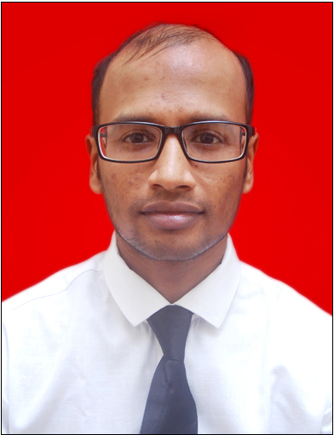

Languages Known: -

- English

- Hindi

CAREER OBJECTIVE

To apply my specialized knowledge & skills in a challenging position whereby my interest and talent can be utilized and developed, in order to benefit the company and assist in my career development within the organization and to seek a job that gives me a chance to express myself.

Executive Summary

Worked in Snehanjali as sales executive.

Organization : SNEHANJALI

Nature of Business: sales

Duration : FEB 2015 to Till Date.
Designation : Sales Representative

Job Profile : SALES REPRESNTATIVE S

- Customer services on receptions & on phone calls.
- Sales of laptops ,Tv’s & Cell phones

- Allocates tasks accordingly amongst team members for smooth operation of company in absences of team leader.

- Ensure all systems are clean and ready for demo to customers.

- Monitor new products which will be of great help for the company & great use for the customers.

- Helping other co-workers in their work and motivating them.

- Handle staff question, complaints, and issue and take corrective measure to resolve it which leads to excellence and experience.

Interests:

Music, Traveling, Sports & Games.

–––––––––––––––––––––––––––––––––––––––––––––––––––––––––––––––––––––––––––––––––––––––––––––––––––––––

Job Profile 2: SALES REPRESNTATIVE

- Sales of laptops, computers & computer parts .
- Taking care of all equipment in absence of seniors.

- Handling cash counter.

- Repairs of pcs & laptops.

Executive Summary

Worked As Sales Representative in

Sunil Shopping Center

Organization : Sunil Shopping Center

Nature of Business : Sales of Computers & Laptops
Duration : Feb 2014 to Jan 2015
Designation : Sales Representative

–––––––––––––––––––––––––––––––––––––––––––––––––––––––––––––––––––––––––––––––––––––––––––––––––––––––

Interpersonal Skills :

- I am a very responsible and confident individual. I believe a lot in myself and my abilities. I have good sense of communication and command over the English language. I can easily adjust in any environment, hence making a good team person. I am a fast learner, thus making it enjoyable to learn new concepts and system of work.

- I am extremely ambitious. Upon learning the insights of my team including its strengths, weaknesses and other aspects, I can also prove to be a worthy leader. Being mature and understanding I also keep the useful ability to counsel people and hence can prove to be a solution provider in crisis situations given the relevant information for the situation. On being guided initially, I can prove to be an asset to any organization

Academic Qualification:

- SSC Passed in 2008 at Bombay Cambridge School

- HSC Passed in 2011 at M.k shanghvi Collage

- T.Y.BCOM Passed in 2014 at M.k shanghvi Collage

–––––––––––––––––––––––––––––––––––––––––––––––––––––––––––––––––––––––––––––––––––––––––––––––––––––––

Functional Skills:

- Good communication skills
- Helping the customer to choose which products suits him best
- Giving complete knowledge of product in a manner they can understand (in simple language)

Unique Quality:

- Excellent communication.

- Good presentation and excellent personal organization.

- Comfort with Shifts.

Declaration:

I declare that the information whatsoever have been provided in above CV is true and accurate of the best of my knowledge. I hope you will consider my application and give me an opportunity to serve under your kind control.

