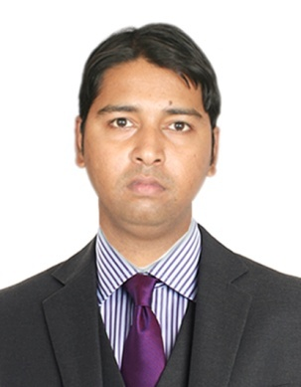  Mohd  Mohd.331375@2freemail.com  Personal Profile  Date of Birth : 27 Aug 1988.  Nationality : Indian  Marital Status : Single  Known Languages: English,UrduHindi and Telugu.  Hobbies: Listening to music, surfing internet. | CURRICULUM VITAE  CAREER OBJECTIVES  Experinced IT/Networking Engineer Seeking similar position in well progressive organisation. The position should allow for advancement of skills in networking and system administration as well as the application of new and innovative techniques and technologies of networking.  WORK EXPERIENCE  - Worked as a senior TECHNICIAN in Sharp Communication Broadband (isp) internet service provider from the period of 3years.  - Worked as a CCTV Technician in Max computers from the period of one year  Executes the installation, termination, testing and labelling of cabling systems according to industry standards.install, modifies, repairs and maintains voice and data cabling systems and survey installation areas to determine work methods, tools, materials and equipments.​  install new cable lines and also perform maintenance on existing cables, including evaluation tests and repairing old or malfunctioning cables. cut and splice fiber optic cables, locate problem areas and perform other repairs as needed also install and maintain network systems for private lines and determine solutions for any issues preventing the service from operating normally.  - Good knowledge in CCTV, ELV SYSTEM, ACCESS CONTROL.  DUTIES AND RESPONSIBILITIES:  - Abilities of pleasant Greetings.  - Interactions with the customer in polite manner.  - Ensure the customer satisfaction.  - Having complete product and process knowledge.  - Assure there is no financial loss to the customers.  - Daily monitoring & observing the updates of product.  - Ensure to meet the challenging KPI’s.  SUMMARY:  - Strong ability on logical analysis and problem solving/trouble shooting.  - Confident at meeting challenges, Punctual, Self-Starter. Good at inter-personal Skills.  - Effective team work, Time Management Skills. Ready to work even in shifts, and travel if required.
ACADEMIC QUALIFICATION:
INTERMEDIATE :-
Percentage: 70%
College : KARV Jr.college
Board : Board of Intermediate education, Andhra Pradesh.
Year of passing: March 2013

SSC :- Govt Boys high School Erramanzil
Percentage : 75%
Board : Board of secondary education. Andhra Pradesh.
Year of passing : March 2010
TECHNICAL SKILLS
- Hardware and Networking.
- Completed course on CCNA,CCNP,CCNE.
- Completed course on MCSE(Microsoft Certified Solutions Expert)
- Operating Systems: Windows XP, windows 7, window 8,window 10,windows vista
STRENGTH
- Excellent interpersonal and communication skills.

- Excellent coordination, multitasking and organizing skills
- Can handle immense pressure & responsibilities
- Confidence and Dedicated
- Adaptability to any environment

DECLARATION:
I hereby declare that the above furnished details are fully true to the best of my knowledge and belief.

