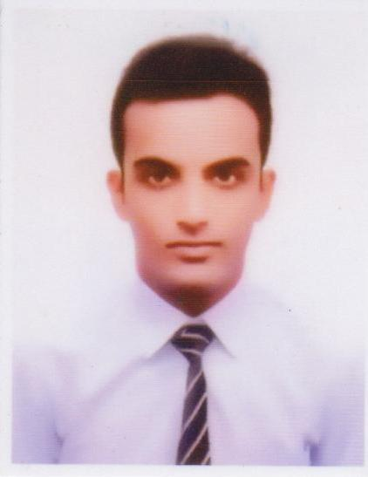
CURRICULUM VITAE
FAZLE
FAZLE.331404@2freemail.com

CAREER OBJECTIVES:
A competent, dynamic, highly motivated professional with excellent communication, negotiation and inter personal skills now seeking a suitable position in your organization where I can utilize my skills and abilities in that offers professional growth and security while being resourceful, innovative and flexible.

PERSONAL ATTRIBUTES:
Highly organized, flexible and versatile team player who will work hard and excel in any environment. Dedicated and committed, willing to take on challenging roles, tough assignments and work to tight deadlines.

PROFESSIONAL SUMMARY:
ACCOUNTS EXECUTIVE: S.C.SHAHS & CO.PVT LTD, Chennai India(From AUG 2014-To OCT-2016)
Key Responsibilities:
- Monitor accounts for delinquency and make daily collection calls, follow-up to obtain payments.
- Collect accounts by discussing situation with customer; obtaining payment; developing a solution by working with customer and the sales department.
- Maintaining the payments and receipt voucher book daily.
- Regarding the sales exchange outstanding amount from exchange person.
- Handling the sales invoice bills and material receipt notes updated in computerized.
- Follow up the customer’s purchases paid in card payment at closing time we have to get settlement file from card machine and make next day receipt in computerized.
- Updating all customers’ information on a system called MAIL and CMS.
- Maintaining the finance receipt weekly who can bought in finance and follow up outstanding file from finance ltd.
- Ensured timely we have to tally the amount main cash and petty cash what should be shown in computerized.
- Making every month daily statement report what we done in computerized and main cash and petty cash vouchers book submit in corporate office.
ADMINISTRATIVE OFFICER – NINE STAR CALL DRIVER AND TRAVELS (Chennai)
Key Responsibilities:
- 18 months experience in Administrative officer in Chennai (2013).Part Time
- Administrative: Adeptly handle customer’s calls, allotting driver, arranging valet parking, making travel arrangements to customers.

HIGHLIGHTS:
- Computer literature: Microsoft Word, Microsoft Office,Power Point, Excel, tally erp9 and focus software.
- Excellent skills in communication and negotiation
- Possess excellent interpersonal, written and oral communication skills
- Ability to work in a team fostered environment
- Maintained an organized portfolio.
- Observant and able to recognize good ideas
- Able to work under pressure and review.

EDUCATIONAL QUALIFICATION:
COURSE | INSTITUTION | UNIVERSITY | PERCENTAGE | PERIOD OF STUDY
B.COM corporate secretary ship. | THE NEW COLLEGE (Autonomous)- Chennai | Madras University | 59.8 % | 2011-2014
HIGHER SECONDARY | Muslim higher secondary school - Chennai | State Board | 62.2% | 2010-2011
S.S.L.C | Muslim higher secondary school - Chennai | State Board | 63.2% | 2008-2009

PERSONAL DATA:
SEX : Male
DATE OF BIRTH: JULY 3,1993
NATIONALITY : Indian
MARITAL STATUS : Single

