MEHBUB
MEHBUB.331434@2freemail.com

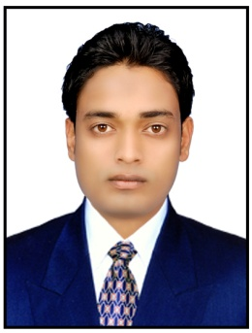

ACCONTANT

KEY SKILLS
- Office Skills: Telephone & Front Desk Reception  Customer Service  Filing Database & Records Management  Data Entry (35 WPM)).
- Computer Skills : Word, Excel, Photoshop, Outlook , Internet, XP/windows 8
- Others: Excelled in Communication and Interpersonal skills.
- Excelled in handling a variety of customer service and calmed upset/angry customers and resolve their issues with expediency
- Praised by HOD for excellent performance as an Account Assistant during his Eight-week leave.
OBJECTIVES

- To work in an organization that highly values ethical behavior towards their employees and which provides an opportunity for growth and upgrade one’s skill and enhance one’s future
ACADEMIC QUALIFICATIO
- S.S.C from Secondary Education Board of Assam (Assam)
- H.S.C from Assam Higher Secondary Education Council (Assam)
- Bachelor of Arts from Guwahati University

PROFESSIONAL EXEPERIECNE

- Worked as a Computer Operator in SDO Civil Office(Assam) as Freelancer
- 6 months as a Senior Salesman at Ajmal Perfumes.
- 6 Months worked as a Receptionist at Koyla Hotel
- 2 Years Experience as a Accountant at Tokyosat Group of Companies, Dubai, U.A.E

PASSPORT DITAILS
Date of Issue : 24th July 2012.
Date of Place : Assam Date of Expiry : 23rd July 2022.

PERSONAL DETAILS

Date of Birth : 31st Dec-1991.
Marital Status : Unmarried
Sex : Male
Nationality : Indian
Religion : Islam
Language Known : Fluently in English with Neutral accent, Hindi & Urdu.
Capabilities : Hard Working, Never Quitting & Self Deterministic
Sincerity and interest in work.

DECLARATION

I hereby declare that the above-mentioned information are correct up to my knowledge and I bear the responsibility for the correctness the above-mentioned particulars.

