KAMRAN (RESUE)
KAMRAN.331443@2freemail.com 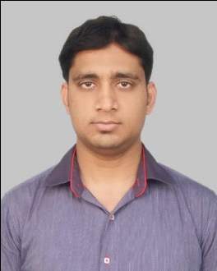

Objective | To excel as a professional in an organization which can provide me motivating milieu to foster my technical and innovative skills and where I can work for the development of the organization.
Scholastics  project Report | B. Tech:  Four years Degree in Computer science from Dr. M. C. Saxena College Engg. & Tech., Lucknow affiliated to GBTU UP.  - 60% marks in First year in session 2010-11.  - 61% marks in Second year in session 2011-12.  - 64% marks in Third year in session 2012-13  - 70% marks in fourth year in session 2013-14  construction plus  H O D - Masooma Nigar  under the guidence of - Mr Rishabh srivastava  High School:  from A.I.C. Inter college Kaushambi affiliated to UP BOARD in 2004.  Intermediate:  from A.I.C. Inter college Kaushambi affiliated to UP BOARD in 2006.  B A  from kanpur university in kanpur up 2007 to 2010
Computer Proficiency | Language Knows: C++ and PHP.  DBMS: Oracle.  Operating System: Windows XP, 7, 8.  Web Designing: HTML, CSS ,Java Script.
Personal skills  Other Skills | - Quick learner, Self-Motivated, Hard Working & Solution Maker.  - Ready to take challenges and meet deadlines.  - Can work effectively in a team, as well as individually.  Database administrator
Extra Curricular activities | - Active Participation in Sports & Competitions.  - Alphaphotosoft pvt Ltd of 2 year 2 month AHM post  - at lucknow up
Personal detail | Date Of Birth: 15 may, 1989  Hobbies: Listening to Music, Reading books.sport,
Language knows: Hindi and English.
Nationality: Indian

I hereby declare that the above mentioned information is true to the best of my knowledge.

