Respected Madam/Sir,

I am seeking challenging position that best utilizes my skills, vast experience and allows opportunities for my personal growth as well as to contribute and be an asset for the development of the company.

I believe the position necessitate an applicant who can work well under pressure, and is able to deal with people in departments throughout the firm. These are the skills I developed in my latest work. I am highly motivated, persevering individual with good interpersonal skills. I am also very hard working person who’s always willing to learn.

I hope my background and achievements will suit your requirements well. I am confident that I can perform the job effectively, and I am ecstatic about the idea of working for a vigorous and impressive firm.

Your favourable consideration and offer will be thankful and grateful.

Thank you.

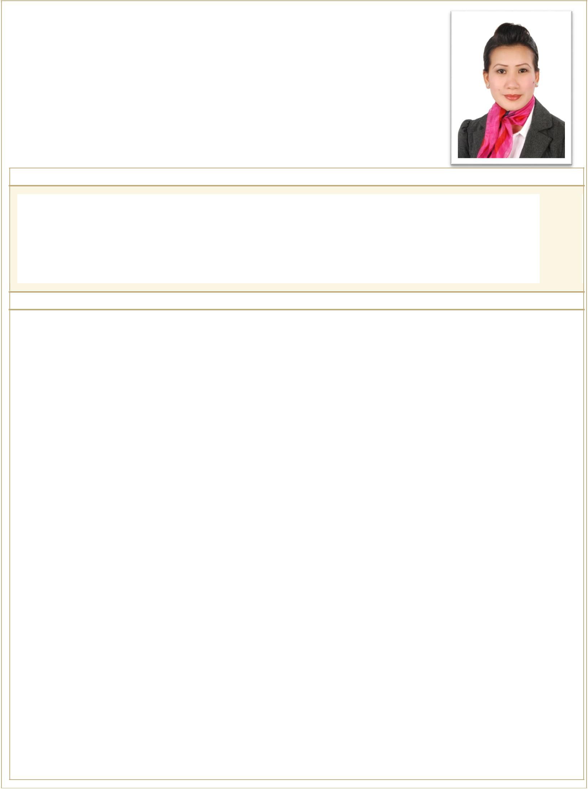
ROMALIN

Visa Status: Transferrable
ROMALIN.331449@2freemail.com

Personal Information:

Employment Details and History :

EMPLOYER POSITION

Responsibilities

EMPLOYER POSITION

Responsibilities

Abu Dhabi, U.A.E.

July 2012 up to Present

Store In Charge

Receive, distribute and maintain adequate quantities of stocks at all times Maintain optimal stock levels;
Handle client complaints immediately.
Promote inventory related awareness programs
Assisting with planning and attending special events when required. Keeps and updates records of good received and issued

Assisting in achieving the company’s maximum profitability and overall success by controlling cost and quality of service

Attendance and participation at any company meeting. Review physical inventories periodically

To plan for effective and efficient Store operation

Cafe Moka, Quatro Group of Companies, Abu Dhabi, U.A.E.

September 2008 up to June 2012

Restaurant Supervisor

Oversees and supervises daily operations of the restaurant .
Prioritizes, schedules, assigns, trains, reviews and evaluates assigned restaurant staff.
Delegates and oversees bartending, kitchen supervision and table service duties. Resolves routine problems encountered in performance of work assignments.

Monitors integrity of restaurant operation and the provision of services. Oversees menu planning, pricing and banquet operations.
Monitors integrity of restaurant operation and the provision of services. Performs other related duties as assigned.

September 2007 up to August 2008

 | Endorse both sophisticated and simple products such as cosmetics, appliances,
 | clothing, shoes, sport wear, household products, etc.
 | Interact with consumers and give them information to help them choose what
 | products to buy.
 | Most concerned with promoting products to create a lasting impression among
Responsibilities | consumers to improve product sales and market preference of a brand name.
 | Promoters work in a variety of locations; generally anywhere with large crowds and potential
 | contests or by distributing brochures in public. Promoters also give product demonstrations.
 | confidence in a product and its manufacturer. Some promotions are designed to generate
 | immediate sales through impulse buying, such as promoters in shopping malls that offer
 | perfume samples to women passing through a department store, while others increase the
 | potential for future sales through brand awareness.

EMPLOYER

Responsibilities

August 2005 up to August 2007

Airport Ground Staff/ Ticketing Staff

Inside the Airport Terminal

Checking passengers in for flights.
Re-routing or re-booking passengers whose flights have been cancelled of delayed.

Assisting disabled passengers or those travelling with young children.
Giving passengers up-to-date information on flights
Assisting passengers with all enquiries, including lost or delayed baggage.

Assisting staff in carrying out security checks as and when the situation arises. Delivering high levels of customer service to passengers and those travelling
through the airport.
Outside the Airport Terminal
Handling all the loading and uploading of passenger bags from the aircraft.
Helping direct passengers on to and off the aircraft.
Directing landed aircraft to taxi spots.
Providing services such as steps from the aircraft for passengers and crew to disembark the aircraft.

EMPLOYER POSITION

Responsibilities

Makati Medical Centre, Philippines

July 2004 up to July 2005

Greet persons entering establishment, determine nature and purpose of visit, and direct them to specific destinations.
calculators or computers to work with balance sheets and other documents. Transmit information or documents to customers using
mail.
Maintain appointment calendars.
Record and distribute phone messages.
Maintain working knowledge of MS Office.
Present a professional demeanor at all times.

Education Details :

 |  | Care Giver |  | Available Caregiver School, Inc. |  | Philippines |  | March - 2006
 |  | B.S. Nursing |  | De La Salle University |  | Philippines |  | March - 2004

 | Training Name |  |  | Institution
 |  |  |  | Abu Dhabi Food Control
 | Essential Food Safety Seminar
 |  |  |  |  | Authority
 | Cardio Pulmonary Resuscitation Training |  |  | Saudi Hearts Association
 |  |  |  | CARELINK Health Care
 | Nursing Procedures on Bedside Care
 |  |  |  | Services Co.
 | Seminar Regarding Career Talks |  |  | Lyceum Guidance Counselling
 | First Aid and Different Stages of Growth |  |  | CARELINK
 | And Development |  |  |  | Co.
 | On the Job Training for Nursing |  |  | Beirut General Hospital
 | On the Job Training for Nursing |  |  | Home for the Aged Tokyo Japan
 | Recent Advances in Medical
 |  |  |  | St. Luke’s Medical Centre
 | Emergencies

 | Start Date |  |  | End Date
 | FEB - 2013
 | JAN - 2007
 | APR - 2006
 | OCT - 2006
 | MAY - 2006
 | FEB - 2003
 | DEC – 2002 |  |  | JAN - 2003
 | SEPT -1999

 |  | Computer Skills |  | Communication Skills |  |  |  | Writing Skills
 |  | MS Word |  |  |  | English |  |  | English
 |  | MS Excel |  |  |  | Filipino |  |  | Filipino
 |  | MS PowerPoint |  |  |  | Arabic
 |  | MS Spread Sheet |  |  |  | French
 |  | Data Base

