CURRICULUM VITAE
KARAN
KARAN.331463@2freemail.com
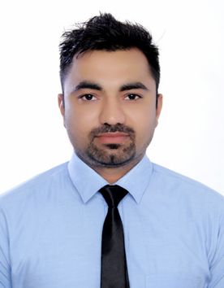

PERSONAL DETAILS:
D.O.B : 20-Oct-1992
Nationality : Indian
Languages known : English , Hindi , Punjabi , Urdu

CAREER OBJECTIVE:
I want to do work in highly challenging environment, where I can use my knowledge and skill in the overall development of the company by working as its team member and I want to do work under the environment where I can groom by the hidden talent and done with best of my ability.

WORK EXPERIENCE:

. Maharaja Hotel
Hoshiarpur , Punjab , India
Nov 2011 to June 2012( Room Attendant)

.Golden Tulip Hotel,
AL Fardan center,
Sahrjah , UAE
July 2012 to June 2014 (Floor Supervisor)

. Yassert Gloria Hotel
Internet city,
Dubai, UAE.
June 2014 to August 2014 (Floor Supervisor)

. Customer Awareness training

. Hotel President
Hoshiarpur , Punjab ,India
Sep 2014 to May 2015 (Supervisor)

. Nice Computers ,
Hoshiarpur.Punjab , India
June 2015 to Feb 2016

. Sharjah,UAE
June 2016 to Present

RESPONSIBILITIES:
.Leading a team of Room Attendants to maintain rooms to the highest standard possible.
.Cleaning and setting up all guest rooms.
.Rearranging and assembling furniture in rooms.
.Inspecting the work of cleaners for conformance to prescribed standards of cleanliness.
.Reporting any maintenance issues to senior Maintenance Managers.
.Carrying out various cleaning tasks.
.Moving furniture to clean under and behind it.
.Disinfecting and deodorizing toilet bowls and lavatories.
.Ensuring that housekeeping materials and equipment are maintained and used correctly.
.Managing all handovers in a professional manner.
.Reporting persistent staff absences to the HR Manager.
.Carrying out any reasonable guest requests.
.Creating a list of rooms that have to be cleaned immediately.
.Informing managers about the status of cleaned rooms.
.Safeguarding the personal items of guests
.Changing bed linen and towels
.Making beds
.Vacuuming floors dusting and polishing furniture
.Cleaning bathrooms replacing stocks of guest supplies such as shampoo and soap
.Re-stocking drinks in the mini-bar

EDUCATION:
. +2 in S.D Senior Secondary School Hoshiarpur.
. 3 Months Computer Diploma.
. Diploma in Computer Applications.

COMPUTER SKILLS:
. Microsoft word
. Microsoft power point
. MS Excel
. Photoshop
. Well knowledge In Tally with Basic Accounting

. Fire safety
. Image protection
. Have well Communication skills
. Hygiene and safety
.I am an good Athlete also.

STRENGTH:
. Optimistic approach and never say die attitude.
. Experience of working in a group and leading a team.
. Open to new ideas.
. Can very well handle to staff.
.Handworker and Dedicated more than others.
. Can work in Accounts with Tally.

