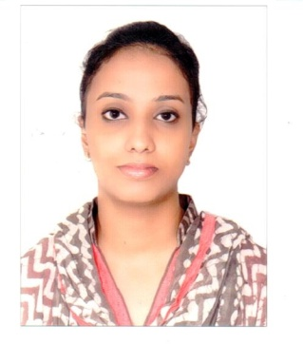
NIJO
NIJO.331472@2freemail.com

OBJECTIVES
To actively contribute to the development and growth of the organization where my analytics skills and practical experience could utilized to the fullest extent and in the process gaining more knowledge and experience to achieve my career objective.
EMPLOYMENT RECORD

AUGUST 2015 – NOVEMBER 2016 Receptionist cum Procurement in-Charge
DMC, Dubai, UAE

Roles:

- Prepare quotation
- Inquire prices for Non Stock items from Local Market
- Prepare Receipt & Payment vouchers
- Documentation of Files as required by ISO
- Prepare other Reports as per required
- Surfing of material
- Attend call and clarify all doubts regarding any products .

JUNE 2014 – DECEMBER 2014 Receptionist cum Assistant Procurement
ESSA MARINE EQUIPMENT LLC Diera, Dubai, UAE
Roles:
- Ability to handle the customer
- Good interpersonal skills
- Good customer relation skill
- Telesales also carried out for urgent clients
- Prepare quotation around the clock
JANUARY 2012 TO APRIL 2013 NURSE DR.BALABHAI NANAVATI HOSPITAL (VILE PARLE-MUMBAI)

Roles
▪ Maintain records of patients
▪ Assist Doctors
▪ Pre-Surgical & Post-Surgical of Patients
▪ Assisting Sr. Doctors in Intensive Care Unit

TECHNICAL SKILLS

Computer Literacy:

• MS Outlook 2013
• MS Office 2013 (MS Word, MS Excel (Formulas),MS Access)
• Short Hand WPM 30
EDUCATION QUALIFICATION

• General Nursing & Midwifery [GNM] (January 2012)
• Higher Secondary Certificate (2008)
• Secondary School Certificate (2005)

PERSONAL INTEREST
Shopping | Traveling | Reading | Music

PERSONAL INFORMATION
Marital Status : Married

Date of birth : 8th November, 1986

Nationality : Indian

Language proficiency : English, Marathi, Hindi, Malayalam,

PASSPORT DETAILS

Place of Issue : Dubai

Issue Date : 23/01/2013

Expiry Date : 22/01/2023

Visa Status : Husband Visa
REFERENCES
References are available on request.

I hereby declare the above particulars are true and accurate to the best of my knowledge

NIJO

