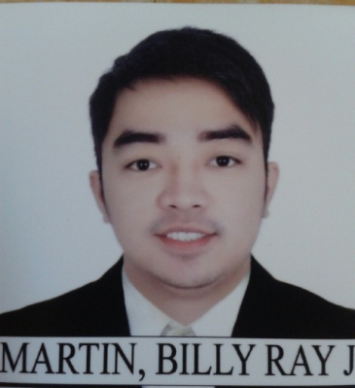
Billy
Billy.331543@2freemail.com

Objective:
To be part of an organization that provides opportunities to broaden my knowledge and teaches new learnings for more improvement in my career.

Educational Attainment:

College : Bachelor of Science in Hotel and Restaurant
Management
Bulacan State University
City of Malolos, Bulacan
2008 – 2012

High School : Liceo De Pulilan
Pulilan, Bulacan
March 2005

Elementary : Plaridel Elementary School
Plaridel, Bulacan
April 2001

Work Experiences:

(Senior Associate/Supervisor)
Makati City, Philippines
May 2016 – November 2016

Hotel H2o (Team Leader/Supervisor)
Lunet, Manila, Philippines
May 3,2015 – May 11,2016

Hotel H2o (Room Attendant)
Luneta, Manila, Philippines
March 4,2012 –April 30, 2015

Walter Mart Supermarket
Bagger / Sales Representative
Waltermart, Plaridel, Bulacan Branch, Philippines
December 12,2008 - July 16,2008

Greenwich Pizza Corporation
Back-up / dinning
Walter Mart,Plaridel, Bulacan Branch, Philippines
September 18, 2006 – March 18, 2007

Seminars Attended:

HOTEL SALES MARKETING EXPO:
“Phenomenal Ideas – The Hotels of the Future”
Hiyas ng Bulacan Convention Center(Pavillion)
City of Malolos, Bulacan

EVENT SALES SEMINAR, BANQUET SERVICE SEMINAR,
HOUSEKEEPING SEMINAR AND HOTEL TOUR
February 5, 2010
Diamond Hotel Malate, Manila

ASIAN CUISINE AT MAKANSUTRA ASIAN FOOD VILLAGE
February 5, 2010
Manila Ocean Park, Luneta, Manila

BAR EXPOSURE PROGRAM
February 4, 2010
T.G.I.F Robinson Place, Manila

TABLE SET-UP AND PLATING FOOD PRESENTATION
February 4, 2010
Tamayo’s Ozeano Fusion Restaurant

Personal Background:

AGE: 28
STATUS: Single
BIRTHDAY: November 7, 1988
BIRTH PLACE: Plaridel, Bulacan, Philippines
GENDER: Male
RELIGION: Methodist
LANGUAGE: English, Tagalog
HEIGHT: 5’7”
WEIGHT: 70 kgs
Dear Sir/Ma’am
This to let you know of my interest in becoming a part of your institution. The enclosed resume will furnish with information concerning my overall employment background, training, education and skills. My work abilities are backed up with experience and knowledge. I assure you that I can successfully fulfill any obligations requiring of any responsibility upon your company in the near future.
Thank you! Godbless and be well,
I hereby certify that the above information is true and correct to the best of my knowledge.

