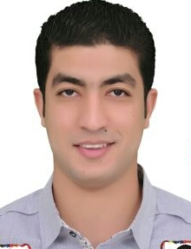
Mohamed
Mohamed.331564@2freemail.com

Personal Data :
- Date Of Birth : 26th of April ,1989
- Nationality : Egyptian
- Religion : Muslim
- Civil status : Married
- Driving license : Available
- Saudi Iqama : Available

Education :
- 2013 graduate from Faculty of Pharmacy,Al-Minya University.

Career Objective :
- Put current qualifications to use to further enhance sales skills and aquire higher professional practice in the area of medical sales.

Courses :
- November 2011 : Egyptian pharmaceutical students federation-pharos university
- April 2012 : First Aid course-Egyptian red crescent
- Selling Skills , marketing course and work shop from faculty of pharmacy -Minya university

Experience :
- May 2015-till now : work as a medical representative at FrieslandCampina-Ksa
- May 2014-april 2015 : work as a medical representative at AstraZeneca- Egypt
- August 2013-May 2014 : work as a medical representative at EVA pharma- Egypt
- Summer 2012 : Training at Sanofi Aventis - Egypt
- July-October 2011 : work at Ehab pahrmacy-Cairo
- Jan-Dec.2010 : work at Badawy pharmacy-Minya

Personal skills :
- Strong work ethics-high level of integrity and moral standards.
- Communication skills:Excellent interpersonal, networking, presentation, persuasion, influencing, negotiation and closing skills.Works effectively in a collaborative environment.
- Responsible and self motivated with positive attitude and tolerance.
- Strong organizational and time managment skills.
- Thinks strategically and analytically,multitasks and priorities.
- Familiar with major computer applications like MS Word, PowerPoint, Excel and the internet.

Languages :
- Arabic : as mother language
- English : very good command of written and spoken

References :
- Available on request

