SANIA.331574@2freemail.com 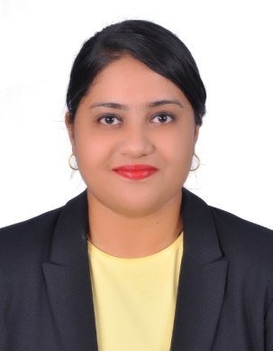

NAME :- SANIA

PERSONAL PROFILE:-

AGE:- 21 YEARS OLD
dATE OF BIRTH:- mARCH 26, 1995
PLACE OFBIRTH:- MUMBAI, INDIA
CIVIL STATUS:- SINGLE
HEIGHT:- 5’8”

CAREER OBJECTIVE

I am looking for a career which offers avenues for carrier and self-development and attribute towards ensuring speedy growth and expansion of the organization that offers me the opportunities to work as well as enhance my knowledge. Organized and has passion for all things in Customer Service. Outstanding Communication & Facilitation Skills.Highly Customer Oriented and pay great attention to detail.

Keen to continue my career in Customer Service and keen to progress with courses & training where needed.

My objective is to work in your company and provide the best of my skills and obtain good relation with clients and co-workers.. I will also maintain good relation with my clients and co-workers.

Professional qualification

Successfully completed IATA Travel & Tourism Foundation/ Diploma in Travel & Ticketing.
Specialized in Galileo Reservation System (GDS) with a score of 97%. Course completed in Mumbai, India.
Proficient in Microsoft Programs such as Excel, Power point, Word & Note, Corel draw.
Successfully graduated in Arts Stream and majored in History and English Literature. Also studied Psychology and Communication Skills.

Academic qualification

2012-2015 Graduated from Mumbai University in Arts stream.
Majored in History and English literature.
Also Studied Psychology and Communication Skills.

2010-2012 Secondary Education HSC. Majored in Science Stream.
Maharashtra Board- Mumbai
Holy Family Convent College.

2002-2010 Grade School
Nazareth Convent High School.
Successfully passed with distinction.

WORK EXPERIENCE

Worked in the Administrative Department of my IATA Institution for 6 Months and gained experience in Communicating with clients and providing service.
__Worked as a Travel Consultant at Jamal Travels in Ras Al Khaimah for 3 months.

RESPONSIBILITIES

-Handle the front office - directing all visitors, including vendors, clients, candidates and customers appropriately
- Screen Incoming calls and direct it to appropriate departments and take accurate and complete messages.
- Order and Manage the Office Stationery supplies
- Manage the routine Office Administrative duties.
- Perform other duties as instructed by the Administration Manager which contribute to the effective office management of the company.
- Coordinate and manage the day to day operations of the Office Assistants
- Handle Travel arrangements when required

TRAVEL & TOURISM CERTIFICATIONS

Certificate of Course Completion from Scube Education Mumbai for Diploma in Travel and Tourism
Certificate of Completion of Galileo GDS ( Computer Reservation System)
Certificate from Travel Port Galileo head office (Delhi) for completion of course

Passportdetails

place of issue : Mumbai, THANE

date of issue : 13 / 11 / 2009

date of expiry : 12 / 11 / 2019

VISA DETAILS

TYPE OF VISA: RESIDENTIAL

I am pleased to mention that I am a quick learner, can get familiarize with any kind of environment in a very short period. A good team player and committed to the task.Ability to handle multiple tasks. Therefore, I am sure I can meet your expectation to achieve the organizational goals with the other team members.
I hereby assure that in the event of given an opportunity to work in your organization, I shall discharge my duties to the satisfaction of my superiors.
I hereby certify that the above information is true to the best of my knowledge

