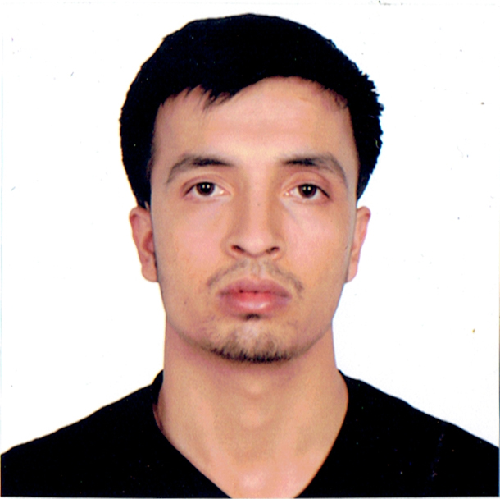
Dipak

Computer Operator

Personal Profile
Date of Birth | : | 22 Feb 1992
Nationality | : | Nepalese
Gender | : | Male
Marital Status | : | Single
Email | : | Dipak.331595@2freemail.com
Blood Group | : | O+Ve

Education
2011-2015 | : | Bachelor of Science in Information Technology  Sikkim Manipal University
2007-2009 | : | Intermediate Level in Humanities  Higher Secondary Education Board
2007 |  | School Leaving Certificate  SLC Board

Relevant Skills
 |  | Microsoft Office Package (Word, excel, PowerPoint, MsAccess)
 |  | Web design, development and coding (PHP, HTML, CSS, Wordpress)
 |  | Graphic design (Indesign, CorelDraw)
 |  | Hardware and networking, familiarity with Linux operating system

Language Proficiency
 |  | English - IELTS score 6.0

Work Experience
Nov 2013 - Dec 2016 |  | Computer Operator  Kalam National Daily Newspaper (Publishing from Pokhara, Nepal)
As a student and work experience in IT sector, I have passion, dedication and enthusiasm regarding learning and working field.
This sector has taught me the value of meeting deadlines. I can demonstrate flexibility, adaptability, versatility for better output.

