SREENATH  SREENATH.331622@2freemail.com | 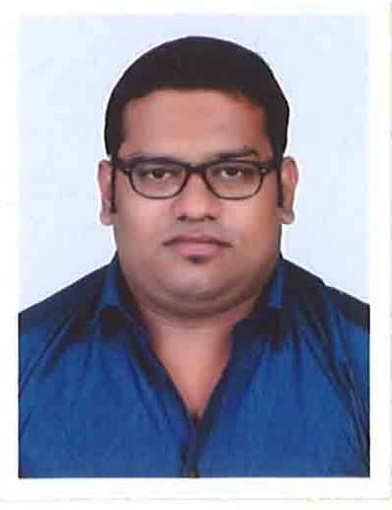

OBJECTIVES

To be a part of a dynamic team within a growing organization where I can contribute to its growth, welfare and development and to seize each and every opportunity to recognize my potential and give my best performance by applying my skills.
EDUCATIONAL CREDENTIALS

CHARTERED ACCOUNTANCY COURSE’s COMMON PROFICIENCY TEST from THE INSTITUTE OF CHARTERED ACCOUNTANTS OF INDIA, INDIA | 2011
Bachelor of Commerce: M.G College Trivandrum, kerala University,  kerala, INDIA.  Major Field of Study : Commerce With Taxation | 2007-2010
Higher secondary : SMV Higher Secondary School, Kerala, INDIA  Major Field of Study : Commerce Group | 2005 - 2007
Secondary School : SVV Nilayam High School,  Kerala, INDIA | 2005

CERTIFICATION

MASTER IN COMPUTERIZED INDIAN & FOREIGN FINANCIAL ACCOUNTING from INTERNATIONAL ASSOCIATION OF BOOKKEEPERS (IAB) (February 2015).
EXPERIENCE

- ADNH (Abu Dhabi National Hotels) in UAE( from JUNE 2016 – Till date)
- Working as an Administrative clerk.

Job Description
- Coordinate between the higher management and operations on all issues related to administrative work
- Liaise with client at all times and communicate their concerns on all services with relevant department heads and to assist in fixing up all issues by improving our services to achieve client satisfaction for day-to-day smooth operations.
- Coordinating daily staff movements between Operations and Head office and maintaining an accurate occupancy records at all times
- Assisting staff on all issues related to their Work, Salary, Medical, transportation, vacation etc.,
- Coordinate with HR department on staff vacations, replacements, medicals, health cards, security passes, and labor cards.
- Handling all other responsibilities assigned by management.
- Complete the task given by management.

2) C.A ANOOPKUMAR & ASSOCIATES – 5th July 2014 to 15th December 2015

Working as an articled assistant cum Assistant administrator

Job Description

- Preparing Accounts using Tally.
- Preparing accounts using MS Excel.
- Monitoring, Coordinating and Supervising.
- E-filing of Return’s.
- Managing financial affairs of various clients.
ABILITIES

- Good Team Player, Ability to Organize
- Deal Effectively With Conflicts, Dedicated & Systematic
- A Good Motivator & Trend Setter
- Reliable & Responsible Work Ethic
- Self-Motivator
- Optimistic and hard working
- Patient and can adapt change faster and act accordingly.

COMPUTER PROFICIENCY

- MS Office (MS Word, MS Excel, MS PowerPoint and MS Outlook)
- Windows 98, 2007 and XP.
- Basics in SAP.
- Typing speed of 40 wpm.
- Well versed in internet& E-Mail.
PERSONAL PROFILE

Date of Birth : 14th September 1989
Marital Status : Single
Nationality : Indian
Language Known : English, Malayalam, Tamil, Hindi
Visa Status : Work Visa(Transferable as ADNH is a semi govt company)

I hereby declare that the particular mentioned above is true to the best of my knowledge and belief.

I will submit all the related references and original certificates upon your request.

