Curriculum Vitae

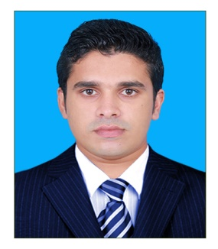
NISAMUDHEEN.
NISAMUDHEEN.331631@2freemail.com

CAREER OBJECTIVE

- Striving for constant improvements and taking responsibility for my own performance by Taking additional responsibility and responding well to situations with minimum supervision.
- Continually seeking to improve performance through individual efforts and with the assistance of others. Seeks feedback on performance and focuses on areas of shortfall. Maximizes opportunities for self-development.
- Ensuring that work quality meets the standards required and completes tasks in a timely and thorough manner with minimum supervision. Follows standards, policies and procedures. Meets attendance and grooming standards.
PERSONAL DETAILS

Date of Birth | 06/07/1987
Nationality | Indian
Marital Status | Married
Passport Number | H6731516

ACADEMIC QUALIFICATIONS

2010 – 2012 | MASTER OF BUSINESS ADMINISTRATION (M.B.A)  (SREE AMMAN INSTITUTE OF MANAGEMENT. ERODE. INDIA )
2005 – 2008 | BACHELOR OF ARTS (BA- ECONOMICS) -  (CALICUT UNIVERSITY, KERALA- INDIA)

COMPUTER EXPERTISE

- Windows-7
- MS Office
- ERP Software’s – Tally,

PROFESSIONAL STRENGTHS

- Flexible and friendly.
- Maintain Positive attitude
- Ability to work under pressure, meet dead lines
- Ability to inspire creativity and co-operation among team members
- Independent and responsible.
- Open minded, organized, productive and practical.
- Good communication skill.
- Self-assured, Self-confident & Self-motivated.
- Focused, ability to learn quickly and deliver quality work.

EXPERIENCE SUMMARY

Designation: Accountant General
Duration : 08/10/2014 To 31/12/2016
Lives in : Dubai

KEY RESPONSIBILITIES

- Ensuring processing of invoice within time in ERP called TALLY.
- Pass Journal Entries and maintain distinct ledger and file for all types
Of transactions.
- Prepare invoices and associated delivery schedule statements.
- Preparing statement of accounts (Receivable and Payable).
- Internal Audit of the Book keeping and Record maintenance.
- Finalization of balance sheet and profit and loss accounts.
- Handling all the cash transaction of the company.
- Maintaining cash and petty cash Records.
- Prepare and send outstanding statement periodically.
- Handle with all customers queries.
- Stock maintenance, store management.

LINGUISTIC CAPABILITIES

- Read & Write : English, Hindi, Arabic.
- Speak : English ,Hindi,

DECLARATION

I hereby state that all the above information provided by me is true to the best of my knowledge and no misrepresentation has been made.

