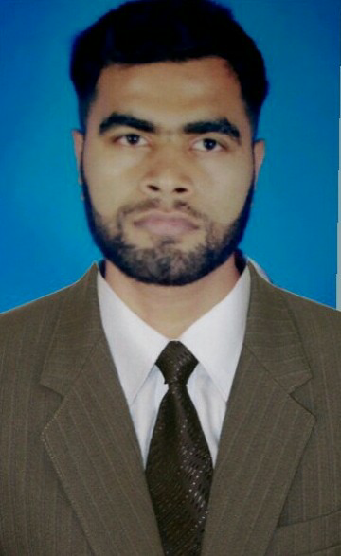

VIGNESH
VIGNESH.331656@2freemail.com

CAREER OBJECTIVE

Seeking a challenging career which demands the best of my professional ability in terms of technical and analytical skills and helps me in broadening and enhancing my current skill and knowledge

PROFESSIONAL EXPERIENCE

One year Worked as Customer support executive in INFOSYS ,TRIVANDRUM on the payroll of LR Infotech Systems from 20-7-2013 TO 31-7-2014
RESPONSIBILITIES:
➢ Technical support for INFOSYS users in installation of Windows OS, and Server OS applications and other drivers
➢ Determines requirements by working with customers.
➢Answers inquiries by clarifying desired information; researching, locating, and providing information.
➢ Maintain the assets of pc's and laptops.
➢ Analyze and troubleshoot software and hardware issues
➢ Train end users on usage of computer hardware and software
➢Resolves problems by clarifying issues; researching and exploring answers and alternative solutions; implementing solutions.
➢ Followed standard procedures for proper escalation of unresolved issues to the appropriate internal team

One and half year Worked as Hardware cum salesSupport Engineer in HITECH SYSTEMS
from 23-4-2015 to 22-6-2016

RESPONSIBILITIES:
Ø Configure new hardware, install and update the software packages
Conducted market research and prepared/updated sales strategies for promoting products according to latest market status/trend and product features.
Evaluated market needs, discovered potential opportunities and identified new sales channels to meet / improve sales agenda of the firm.
Represented the firm at road shows, exhibitions, presentations and meetings with market leaders and clients.
Solved customer issues and provided training/instruction to users with regard to new products
EDUCATIONAL QUALIFICATION

Ø Bachelor Of Engineering from Anna University CHENNAI in 2013
Ø +2 Pass from State board in 2008
Ø SSLC (10th ) Pass from State Board in 2006

PROFESSIONAL QUALIFICATION

➢ CCNA (CISCO CERTIFIED NETWORK ASSOCIATE)

TECHNICAL QUALIFICATION

Hardware skills: PC assembling, Formatting, Partition, drivers Installation
Platforms: Windows server2008,2008R2, windows XP/Vista/7/8
Languages: C, C++
Mail clients : MS Outlook
Others: Assembling & Trouble4shooting of PC's, Windows Update & antivir, Installation & Troubleshooting of operating system's (Win XP/8/8.1,Win 2003server/2008R2 ,Configuring MS Outlook and its troubleshooting,PABX installation and configuration,ITIL knowledge

INTERPERSONAL SKILLS
Ø Good knowledge of Ms office products
Ø Open to new technologies and quick learner
Ø Can be molded to fit into any position
Ø Oriented towards customer service
Ø Good communication skills
Ø Problem solving abilities

PERSONAL DETAILS
Date of Birth : 20-04-1991
Sex : Male
Marital Status : Single
Linguistic proficiency : English, Tamil, Malayalam, Hindi,Arabic(Beginner)
Hobbies : Listeningto music, gardening, andphotography.
DECLARATION

I, Vignesh , do hereby confirm that the information given above is true to the best of my knowledge.

