SURENDER KUMAR – CV No. 1990272  Permanent Address:  S/o Mr Ramprasad  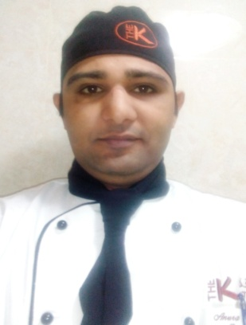  Personal Data  Date of Birth :15/02/1987  Father Name :Mr Ramprasad  Sex :Male  Height : 172cms.  Nationality :Indian  Marital Status :Married  Languages Known:  - English  - Hindi | Career Objective:  Having got an opportunity to study the Hospitality Course from an esteemed institute which has helped me to realize my dreams, be a successful hotelierand have technical expertise as well as managerial skill which best suits the organisation culture is the ambition of my life. Believes in “stay professional and you will never go wrong”.  Snapshots:  - Fifteen days successful Industrial Training from surajkundmelaauthority Faridabad from 1st Feb 2007 to 15 Feb 2007  - Six months training done in HOTEL MARRINA (C .P) new Delhi. from 02 June2007 to 31Dec 2007.  Professional Qualification:  - Basic knowledge of COMPUTER.  - ONE& half Years Diploma from FOOD CRAFT INSTITUTE  (F.C.I)BADKHAL LAKE FARIDABAD (2006-2007)  Academic Qualifications:  UNIVERSITY/BOARDYEAR  INTERMEDIATE Board of Bhiwani 2005  MATRIC Board of Bhiwani2004  Work Experience:  - Presently Working in THE K HOTEL( GULF HOTEL GROUP) JUFFER BAHRAIN as a Chef De Party in Indian curry and tandoor from 27 June2016 to till date.  - Worked in ROTANA CAFE BAHRAIN as a Chef De Party(C,D.P.) IN INDIAN CURRY & TANDOOR DEPT from 21 Sep2014 to 21 June2016.  - Worked inHOTEL BEST WESTERN PLUS THE OLIVE, Bahrain as a COMMI-1 IN INDIAN CURRY DEPT. since 16th DEC 2012 to 23 Sep 2014.  - Worked in TRAVELS FOOD SARVICE IGI AIRPORT T3 New Delhi as a COMMI-2 IN INDIAN CURRY DEPT. from 1st July 2010 to 20 July 2012.  - Worked in HOTEL COUNTRY INN SAUITE BY CARLSON GROUP as a COMMI -3 IN INDIAN CURRY DEPT. from 8 April 2009 to 13 May2010.  - worked in HOTEL NEEMRANA FORT PALACE JAIPUR ROAD NEEMRANA,as a COMMI 3 in INDIAN CURRY DEPT. from 05 Feb 2008 to31 Dec 2008  Key Skills:  - Good communication skills.  - Can work effectively in team, as well as individually.  - Highly adapted to learn new views/ideas/technologies.  - Positive attitude & Young and self dynamic professional.

Hobbies:  - Making Friends.  - Listening Soft Music.  - Playing cricket.  - Internet Surfing.  Strengths:  - Hard working.  - Confident.  - Punctual.  - Smart working.  - Self motivated. | - Responsibilities:  - Training staff according to the company standards.  - Coordinating with vendors and event management.  - Making duty chart and conducting briefing.  - Extra Curricular Activities:  - Continental ,Tandoor& Dessert Department  - Declaration  - I, Surender Kumardeclare that the above information is true and correct to the best of my knowledge and nothing has been concealed or distorted.  Date: ………………  Yours Sincerely,  Place:…………….. (Surendra Kumar)

SURENDER KUMAR – CV No. 1990272

To arrange interview with me, please send your company name, vacancy and salary details to my HR Consultant cvcontacts@gulfjobseekers.com Whatsapp +971504753686

______________________________________

