CV

Husham
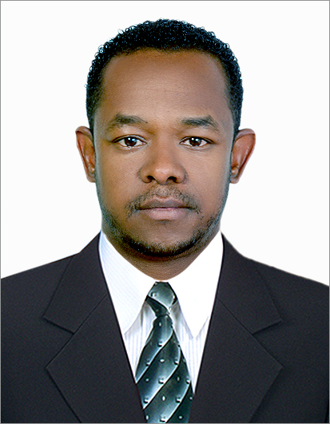
Husham.331726@2freemail.com

Summary:
5 years supervisor and Direct sales Rep skilled in exceeding sales goals
and company expectation by expanding client base by maintaining high
standards of customer service and sales

4 years as a call center Representative who maintains a high level of
Professionalism patience and efficiency to obtain Customer satisfaction and
increase customers loyalty.

Objective: Seeking for a position in Administration, Sales or Customer Service

Highlights:
- High customer service quality standard
- Supervision skills
- Strong planning ability and organizational skills
- Strong ability to solve proplems
- High sales technique

Experience:

Helpdesk Operator
May 2015 – presdent
Enova Facilities Managemant
Responsiple For
- Handle calls which client complaint and asign to technitians to resolve it
- Regisration of all the complains
- Colsing of all pending resolved complains
- Make daily reports

Customer Service & Sales Supervisor
May 2012 – Jan 2015
MTN Telecommunication – Sudan
Responsible For
- Communicate with other department to insure stock avalability
- Handling escalated cases
- Handling dailly and monthly cash report
- Monitoring staff stock

Customer Service & Sales Rep
Aug 2007 – May 2012
MTN Telecommunication – Sudan
Responsible For
- Selling Company products
- Selling and promote Company Services
- Handling complaints
- Cash Handling
- Reporting all transactions during the day and month & CRM

Call Center Representative
Aug 2005- Aug 2007
MTN Telecommunication – Sudan
Responsible For:
- Promoting company services and products
- Explaining procedures
- Solving and follow up problems
- CRM & Reporting.

Education:
1999 - 2002 years Diploma in Computer Science - Aljazeera University

Courses& Training:

1-CRM (Customer Relation Management) by International Center for Quality (ICQ) -
July 2006 (1 week)
2- Business Etiquette for Professional Passage, By (Peace) 1 week

3- Cambridge International Education Certificate from 6/7/2006 to 6/9/2006.
4- Service Quality Management August 2010.(3 days)

5- Sales Techniques Program -- at International Centre for Quality June 2011
6- Advance Excel November 2011.(3 days )

7- Time & Stress Management in International Center for Quality April 2012 (3 days)
8- Up selling & cross selling course Nov 2013 – (3 days)

Languages:
Arabic – Native
English- good

IT Skills:
Microsoft Excel, Word, PowerPoint.
Fast typing skills both Arabic & English

Visa Status: Resident Visa

