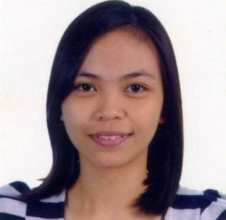
CRYZELLE
CRYZELLE.331776@2freemail.com

OBJECTIVE
Ability to prioritize and handle multiple tasks in a challenging environment, excellent analytical, organizational and communication skills, able to work under pressure with confidence and going out of the way to achieve team goals.

WORK EXPERIENCES
- LABORATORY TECHNICIAN
BIO-SAVE MEDICAL AND DIAGNOSTIC CENTER
19 B. Morcilla St., Villa Eugenia, Pateros, Metro Manila
(APRIL 2015-MAY 2016)
      - Carried out phlebotomy on patients and correctly labeled and handled samples.
      - Cleaned and sterilized laboratory equipments each shift.
      - Assisted in set up, calibration, and operated laboratory equipments and instruments.
      - Prepared various reports and records, graphs and charts.
  - Maintains laboratory records and inventory for supplies and reagents.
  - Maintains clean and sanitary work area in accordance with standard laboratory practice and procedures.
  - Perform laboratory tests using a variety of equipment and reagents.
  - Disposing off specimens and samples appropriately.

- TRAINING/INTERNSHIP
MARY JOHNSTON HOSPITAL
1221 Juan Nolasco St., Tondo, Manila

October 2014 – March 2015
      - Perform phlebotomy and processing of specimens.
      - Review and process orders in laboratory procedures; enter patient data into computer system.
      - Record laboratory results.
      - Was able to handle the following machines: Sysmex XS-1000i Hematology Analyzer, Selectra PRO S and Beckman Coulter CX9 PRO for Clinical Chemistry, BD Bactec FX40 for Microbiology.

AFFILIATION
    - MEMBER – Junior Medical Technology Organization (JMTO) MCU
An organization organized by the students of Medical Technology inside the campus.
June 2010-October 2011

EDUCATIONAL BACKGROUND

COLLEGE
Dr. Carlos Lanting College
Sangandaan, Quezon City
B.S. Medical Technology
S.Y. Oct. 2014 – March 2015

Manila Central University
EDSA, Caloocan City
B.S. Medical Technology
S.Y. 2008-2011

HIGH SCHOOL
Don. Alejandro Roces Sr. Science-Technology High School
Roces Ave., Quezon City
S.Y. 2004-2008

ELEMENTARY
Dalupan Elementary School
Quezon City
S.Y. 1998-2004

PERSONAL DATA

Age: 24 years old
Birthday: August 20, 1992
Nationality: Filipino
Skills: Proficient in Microsoft Office Word, PowerPoint and Excel
Language: Fluent in English and Tagalog

I certify that in the best of my knowledge the above information are true and correct.

