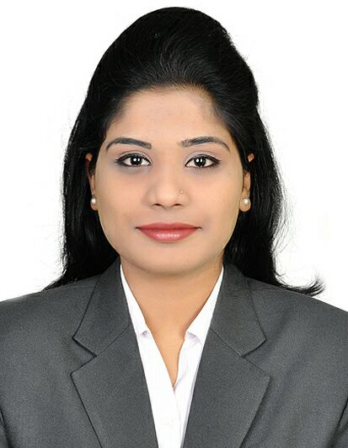
Safia
Administrative Executive

Safia.331808@2freemail.com

Professional Attributes | Maintain and enhance human resources productively in an organization, developing strong manpower, identifying talent and deploying professional development programs in order to achieve organizational goals and fulfill employees’ needs. Seeking Executive position that will enable me to challenge my skills and talents while making tremendous contributions to company
Career Highlights | - Performance management : Appraisals and promotion.  - Recuriting : Oversee interviewing, selecting and hiring process.  - Arranging new-employee orientation.  - Familiarizing new employees with organizational culture,values and goals.  - Executing change management and long and short term management strategies.  - Organizing professional development courses.  - Budget Control, Forecasting Accuracy, Creative Business Plans.
Experience | SITEL INDIA PRIVATE LTD - India  ADMINISTRATIVE / PROCESS Executive Nov 2014- present  Recruitment Management:  - Analyzed staffing requirement and directed the recruitment process – Instructed management regarding effective interviewing techniques using human resources methods.  - Conducted interviews for all management positions and issued hiring recommendations.  Development Programs:  - Devised and implemented various human resource programs to enhance the company’s reputation and ensure amiable relations between employees and upper management.  - Recommended important changes to other departmental managers regarding organizational policies and procedures.  Record Maintenance:  - Maintaining current HR files and databases  - Updating and maintaining employee benefits, employment status, and similar records  GENPACT Pvt Ltd.  internship (Accounts Executive) Dec 2013-oct 2014  - Meet with clients to determine their advertising needs  - Develop and design advertising solutions based on determined needs  - Build and manage core territory plans  - Use resources to sell a program in an effective manner  - Monitor and record sales at each level  - Maintain account awareness for further tapping  - Performed research work for the marketing department  - Provided support to the administration and marketing departments  - Managed email and other correspondence  - Provided information to clients over the phone and in person
Education & Skill Set | - Masters in Business Administration (hr AND fINANCE)  Osmania University June – 2016  - Bachelors in Commerce (Foreign trade)  Osmania University June- 2014  - Well versed with MS- Office packages  - Well versed with accounting packages
Personal Information | - Nationality: Indian  - D.O.B: 12-07-1993  - Marital Status: Single

