  - 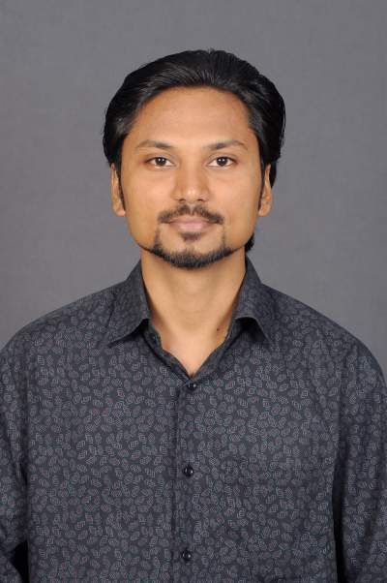

ARAVINDAN
Mail-ID: ARAVINDAN.331820@2freemail.com

ACADEMIA
M.sc (Biotechnology)
PROFESSIONAL CERTIFICATES
NISM-Series-V-A: Mutual Fund Distributors Certification
Technical Skills:
Operating systems: Windows XP/Windows 7
Software Packages: MS Office (Excel, Word & Power point)
Browsers: IE, google chrome
PERSONAL DOSSIER
Date of Birth 26th May, 1985
Present Address
Qusais, Dubai, U.A.E

career objectives

- A self-motivated Marketing Specialist 8 Years’ experience possess domain knowledge in Business Developent & Marketing in Medical Sales.
- Identifying most defective area on basis of Error Analysis and taking necessary training to improve the sales.
- Demonstrated abilities in ensuring quality deliverables to clients within specified timeframe.
- An effective communicator with honed relationship management, client issues solving skills.

Work Experience
Achievers Live Medical Solutions Pvt Ltd, Chennai 7 Years and 4 Months (From August 2009 to Till Date)

Designation: Marketing Specialist

Responsibilities:

- Budgeting, Forecast, business plans, costing, business reviews, strategic planning and development
- Quote & follow up against Government Tender.
- Maintaining stock & placing orders for local and Government order for Medical Consumable products.
- Competitor activity, Business meetings & reviews.
- Participation in Medical Conferences & Exhibition.
- End user visits – Product training & promotion.
- Product launch and market research.

IBM Daksh, Chennai.  1 year and 6 months ( Jan 2008 to July 2009)
Client & process : Citi bank.
Designation:Sr. Customer service executive

Responsibilities:
- Conduct refreshers/huddle on daily basis.
- Resolve customer query over phone.
- Send open mail to client on customer escalations.
- Handle customer escalation calls.
- Deposits & Prepaid card application, Credit card payments.
- If the Borrower is eligible for loan then we need to prepare a loan agreement with borrower acceptable term, Interest rate and Monthly payment etc.

Declaration:
I hereby acknowledge that all the information given above is true to the best of my knowledge.
Yours sincerely,

