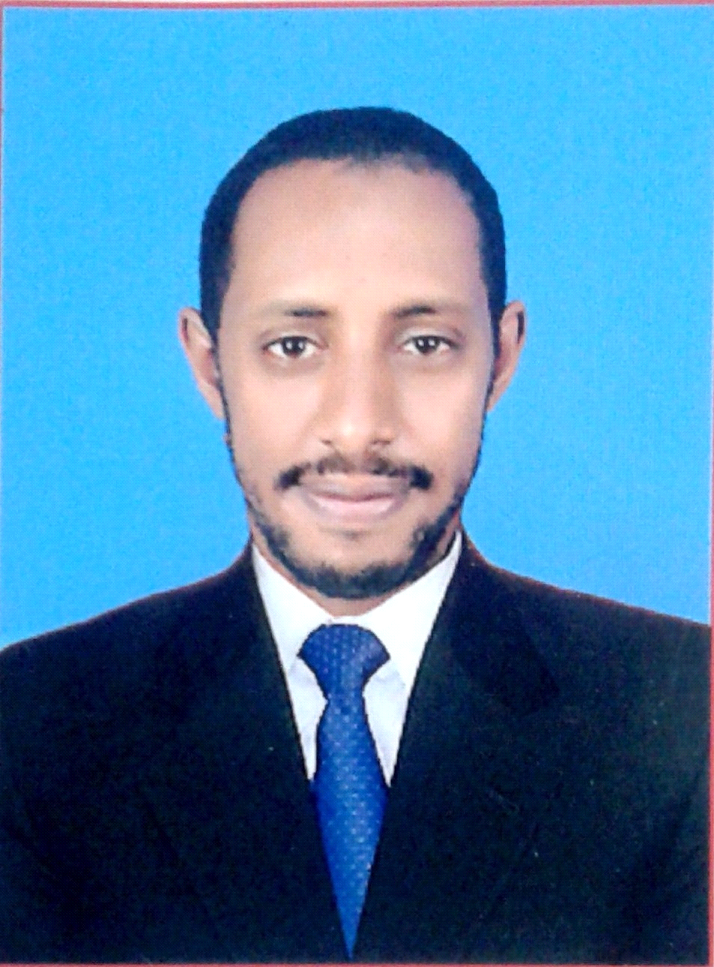
C V
RAMAH
E-mail: RAMAH.331837@2freemail.com

Objective:
To apply my background experience and skills towards a position offering new challenges and responsibilities with ultimate career and personal advancement.
Personal Information:
Nationality : Sudan
Date of birth : 08/09/1988
Sex : Male
Religion : Muslim
Marital Status : Single
Visa Status : resident
Language Known : Arabic, English, Tamil written and spoken.
Academic Achievements:
Bachelor of commerce (computer applications)
B.Com CA Bharathiar Universty-coimbatore India
Technical Skills:
- proficient in the use of Ms-Office (word/excel)
- tally9 ERP and peachtree , quick books
- Good communication skill and team work
- Capable of handling stress easily

