DHANUSH
DHANUSH.331852@2freemail.com

CAREER SUMMARY

9.5 years of Core AR & AP experience and Hands on experience in

▪ | Credit Evaluation | ▪ | AP invoice processing | ▪ | Cash posting
▪ | Vendor master creation | ▪ | Invoices Audit | ▪ | Process deck presentation
▪ | Cash collection forecasting | ▪ | Credit Collections (Voice) | ▪ | Performance Management
▪ | Employee expenses processing | ▪ | Billing | ▪ | Talent Acquisition

PROFESSIONAL EXPERIENCES - PRESENT (IV)

AMEC FOSTER WHEELER INDIA Pvt Ltd, 2016 ~ Till date Assistant Manager ~ Accounts Payables & Accounts Receivables 0.5 Years About AFW: Amec Foster Wheeler plc is a British multinational consultancy, engineering and project management company headquartered in London, United Kingdom.
Major Achievements & Contributions

• Travelled to Thailand and transitioned AP process successfully
• Managing a team of 25 members
• Extraction of AP metrics, Logged suspense reports ensuring to have process control
• Audit of each and every payable invoices before selecting for payment
• Weekly deck presentation to stake holders on AP process
• Performing Bank and employee reconciliation every month end
• Implemented many trackers to get the volume, accuracy data and dashboard preparations
• Involved in Automation of Time sheet process (Reduction of 0.75 FTE)
• Got the best team of the QTR award for significant achievement on meeting the payments TAT
• Involved in reduction of FTE’s in process from 6 to 4 FTE’s (Cost saving to the Organization)
• Streamlined the process DTP’s
• Initiated many Employee Retention & Engagement programs for better work life balance

o Fun @ work , Weekly

o Family Movie, quarterly

o Bay decorations (Seasonal)

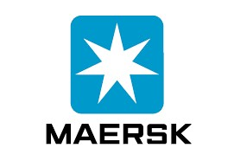2016 2013 2007
PROFESSIONAL EXPERIENCES - PREVIOUS (III)

COMPUTER SCIENCES CORPORATION LIMITED, 2014 ~ 2016

Professional 1 ~ Accounts Receivables 2.3 Years About CSC: Computer Sciences Corporation is an American multinational corporation that provides information technology services and professional services. Its headquarters are located in Falls Church, Virginia. CSC has 56,000 employees in over 60 countries

Major Achievement & Contributions

• Worked in CSC as part of the O2C (AR) and handled a ten member team
• Dealt with Asia Billing process (China & Japan)
• Involved in T&M, Fixed and Milestone billing.
• Collection and verification of billing inputs from the project managers
• Raising the invoices as per the billing Request
• Dealt with Asia, Australia, and South Africa & Middle east Credit collection process
• Monthly ops call deck presentation (Call with CFO)
• Engaged in improving processes through reengineering, system checks, and process automation

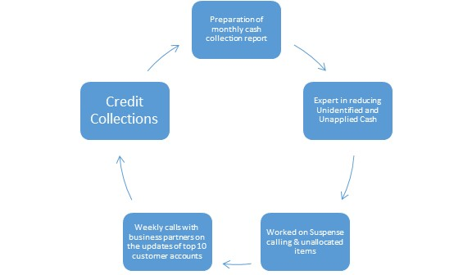
PROFESSIONAL EXPERIENCES - PREVIOUS (II)

MAERSK GLOBAL SERVICE CENTRES, 2013 ~ Dec 2014

Process Analyst (Individual Contributor) 11 months About Maersk: A.P. Moller–Maersk Group, also known as Maersk, is a Danish business conglomerate. A.P. Møller – Maersk Group has activities in a variety of business sectors, primarily within the transportation and energy sectors.
Major Achievement & Contributions

• Dealt with credit evaluation process which is analyzing the credit worthiness of customers to grant credit accordingly.
• Credit evaluation process which was successfully transitioned within a short span of 2 weeks, and I have been recognized for getting the project signed off with good & consistent performance delivered.
• Also dealt with preparation of credit agreement between the
Customer & company for the credit terms granted.

PROFESSIONAL EXPERIENCES - INITIAL (I)

ACCENTURE SERVICES (INDIA) PRIVATE LIMITED June 2007 ~ Sep 2013

Process Analyst (Assistant Team lead) 5.5 Years About Accenture : Accenture PLC is a global professional services company and provides strategy, consulting, digital, technology and operations services. It has been incorporated in Dublin, Ireland, since 1
September 2009. It is a Fortune Global 500 company

Major Achievement & Contributions

• Acted as the Subject Matter Expert (SME) for the Cash allocation & Billing process, this includes UK & US regions.
• Took AR US billing process from onshore through web ex and transitioned successfully.
• Got Accenture ambassador award for exemplary work carried on and 6 more awards as well.
• Processed around 2500 line items within TAT with 100%
Accuracy in a month.
• Coordinated with team members to achieve targets.
• I was one of the quality auditors for PO & non PO Invoices audit of P2P process.
• Delivered many process improvement ideas and
Implemented accordingly which resulted in cost reduction for the project/time savings
EDUCATION & CERTIFICATIONS

Regular Courses
▪ Graduate in Commerce
RKM Vivekananda College, Chennai (2004-2007)

Certifications Program
▪ Six Sigma green belt

PEOPLE & PROCESS ORIENTED COMPETENCIES

▪ | Multi-linguistic | ~ English, Tamil, Telugu
▪  ▪ | Advance knowledge  ERP | ~ Excel (Macros) & PPT presentation  ~ SAP,JDE,TSYS,TALLY

ACHIEVEMENTS IN SCHOOL & COLLEGE TENURE

▪ School House captain - Leader of Band troop

▪ Awarded “Runners up" for 2 consecutive times in Carrom

▪ Overall Championship Shield during Schooling

▪ Organized cultural activities representing commerce department during college.
• Active member of the National Service Scheme and participated in many blood donation camps.
• Won 1 Gold & 2 Silver medals in Inter department cricket

HOBBIES, PASSION & OTHER SKILLS

• Dance Choreography (Did Choreo for 3 Flash mob events in corporate tenure)
• Playing Cricket
• Event Management
• Short film Direction, Poem writing, Photography
• Proficient with usage of Microsoft office.
• Possess good typing speed and swift in Excel.
• Usage of SAP platform.

