Mohamed
Mohamed.331869@2freemail.com
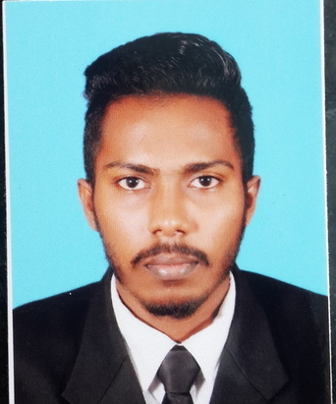

PERSONAL PROFILE

I am an energetic, self-motivated and flexible individual ready to meet demanding challenges, always on a look out for a positive & bigger outlook. I enjoy working in any team environment and I am comfortable in communicating with people at all levels. I am a learner for life and I’m sure that I will adapt to any type of working environment, multi-cultural and be a valuable member of the working team.

OBJECTIVE

Seeking for an employment in an establishment where my knowledge and skills could be utilized towards the continuous growth of the company as well as career development.

PROFESSIONAL QULIFICATIONS

- Currently doing BTECH Higher National Diploma in computing system and development at ESOFT
- Completed Diploma in Hardware and Networking at ESOFT.
- Completed Diploma in Islamic Banking Finance at Mukarramah International School.
- Worked at Legacy Pvt Ltd as a collection executive (Data Entry).
- Worked at Job Envoy as Out Sourcing Executive.
- Worked at Osaka Car Sale as Web Site maintenance and IT executive as well as Assistant Manager (System Administrator).
- Currently working at Spark Electric Vehicles as a System Administrator (E Marketing and Artwork Publishing, Sales Representative, Stock Controller, Website Maintenance, KPM system maintenance) IT coordinator as well as.
- Retail trade Experience at Fashion Bug for one year.
- Have Three Years of working Experience.

SKILLS AND COMPETENCE

- Fluent in written and spoken skills in both English and Sinhala, Tamil

- Excellent computer skills on Microsoft Office Packages and Internet & Email

- Excellent interpersonal skills & communication skills in self-organizing and coordinating ability

- Willingness to learn and work independently

- Helping and volunteering in social activities.
- Website Maintenance.
- Stock Controlling.
- Social Media Updating.
- E Marketing and Artwork Publishing.
- Internet and Emailing.

EXTRA CURRIVULAR ACTIVITIES
 | Club / Society | Position held
 | Interact Club | Member.
 | Information And Technology | President
 | Lion Club | Member.
 | Islamic Society | Member.
 | Google Student | Member.
 | Commerce Society | Member.
 | English Literary Association. | Member.

- Senior Prefect of Mukarramah International School (2011).
- A volunteer of V-Force (under United Nations Volunteers) – Volunteered for the V-awards 2013 as a team lead in the ushering team, participated for the National Volunteer sectaries lunch and participated for National Unity Convention.
- A volunteer in the IMCD Team (International Movement for Community Development).
- Volunteering in World Conference on Youth 2014 (Conference Supportive Leader and Technical, Media).

- National Committee member of a network (International Network for Youth for Peace and Development – INYPD) working with National Olympic Committee (NOC).
- Volunteer at SDJF (Sri Lanka Development Journalism Foundation) for GCRA Conference.
- Participation in leadership programs like Religious Youth Service (RYS) United Peace Federation – Island Fri0endship project and working as a young leader of all faiths together for Peace.
- Trained has an Active Citizen in British Council.

SPORTS ACTIVITIES

- Played Cricket for Asian Cricket Academy in Modhara.
- Basketball player in School Club and Stallion Club.
- Athletics participated in School Sport meet.

ACADEMIC QULIFICATIONS

- G.C.E. O/L’s (2011)

English A

ICT B

Religion B

Science C

Business C

History S

Maths S

Sinhala S

- G.C.E A/L’s (2014)

English B

Accounts S

ICT S

Business Std S

PERSONAL DETAILS

Name in Full : Muhammed

Date of Birth : 11/01/1995

Age : 21 years

Gender : Male

Marital Status : Single

School Attended : Amal International School.

Colleges : Esoft Metro Campus.

I do hereby certify that the above particulars given by me are true and correct according to my knowledge.
Nazik

