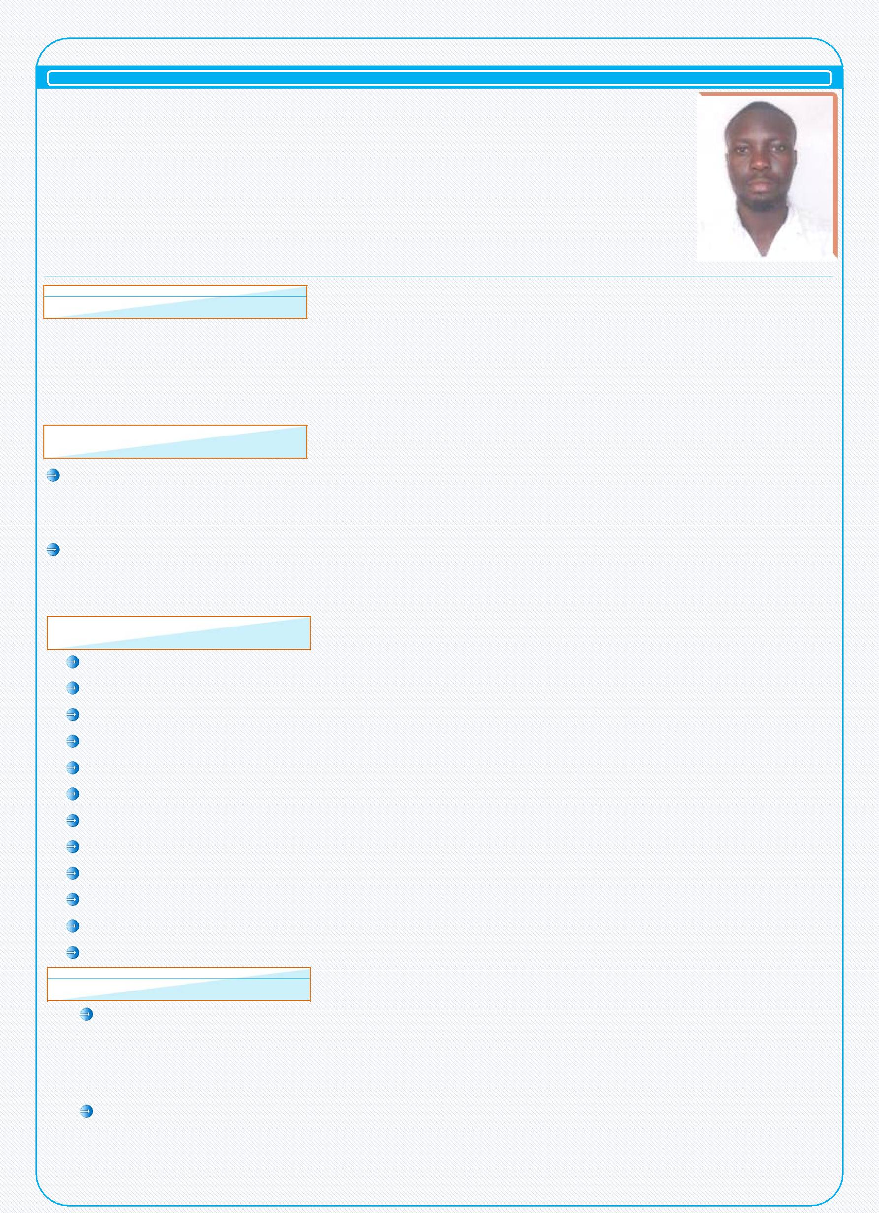
BOLAJI MORUF MAJEKODUNMI – CV No. 1991268

Address: Al Ain, United Arab Emirates

OBJECTIVES

To use my skills in a position that can test my abilities, offer stability and long term growth. Seeking a challenging responsibility with leading company allowing me to fully contribute to the successful achievement of corporate goals and objective, where professional experience skills, intelligence and ambition are utilized to full potentials.

EDUCATION

Lagos State Polytechnic (HND)

Year : 2005 to 2006
Nigeria

Lagos State Polytechnic (HND)

Year : 2009 to 2010

Nigeria

QUALIFICATIONS & SKILLS

Good communication skills and personality.

Pleasing personality to interact with customers enthusiastically. Strong organizational, time management and administrative skills Flexible and quick learner & Dedicated and hard worker.
Able to handle customer complaints effectively.

Ensuring high levels of attention to detail and professionalism.

Smart in appearance as well as professionally confident, polite and welcoming all times. Have exceptional customer and service standard.

Passionate about customer care and offering a first class service to guest. Aware of all relevant security, health and safety issue.

Attention for detail and passion for continues personal improvement. Posses strong organizational skills with a keen eye for detail

EXPERIENCE

Company | :
Position | : | Hall Supervisor\Housekeeping
Period | : | 3 Years to Present
Location | : | Al Ain, UAE

Company | : | ABAD COMPANY L.L.C
Position | : | Forman
Period | : | 4 Years
Location | : | Nigeria

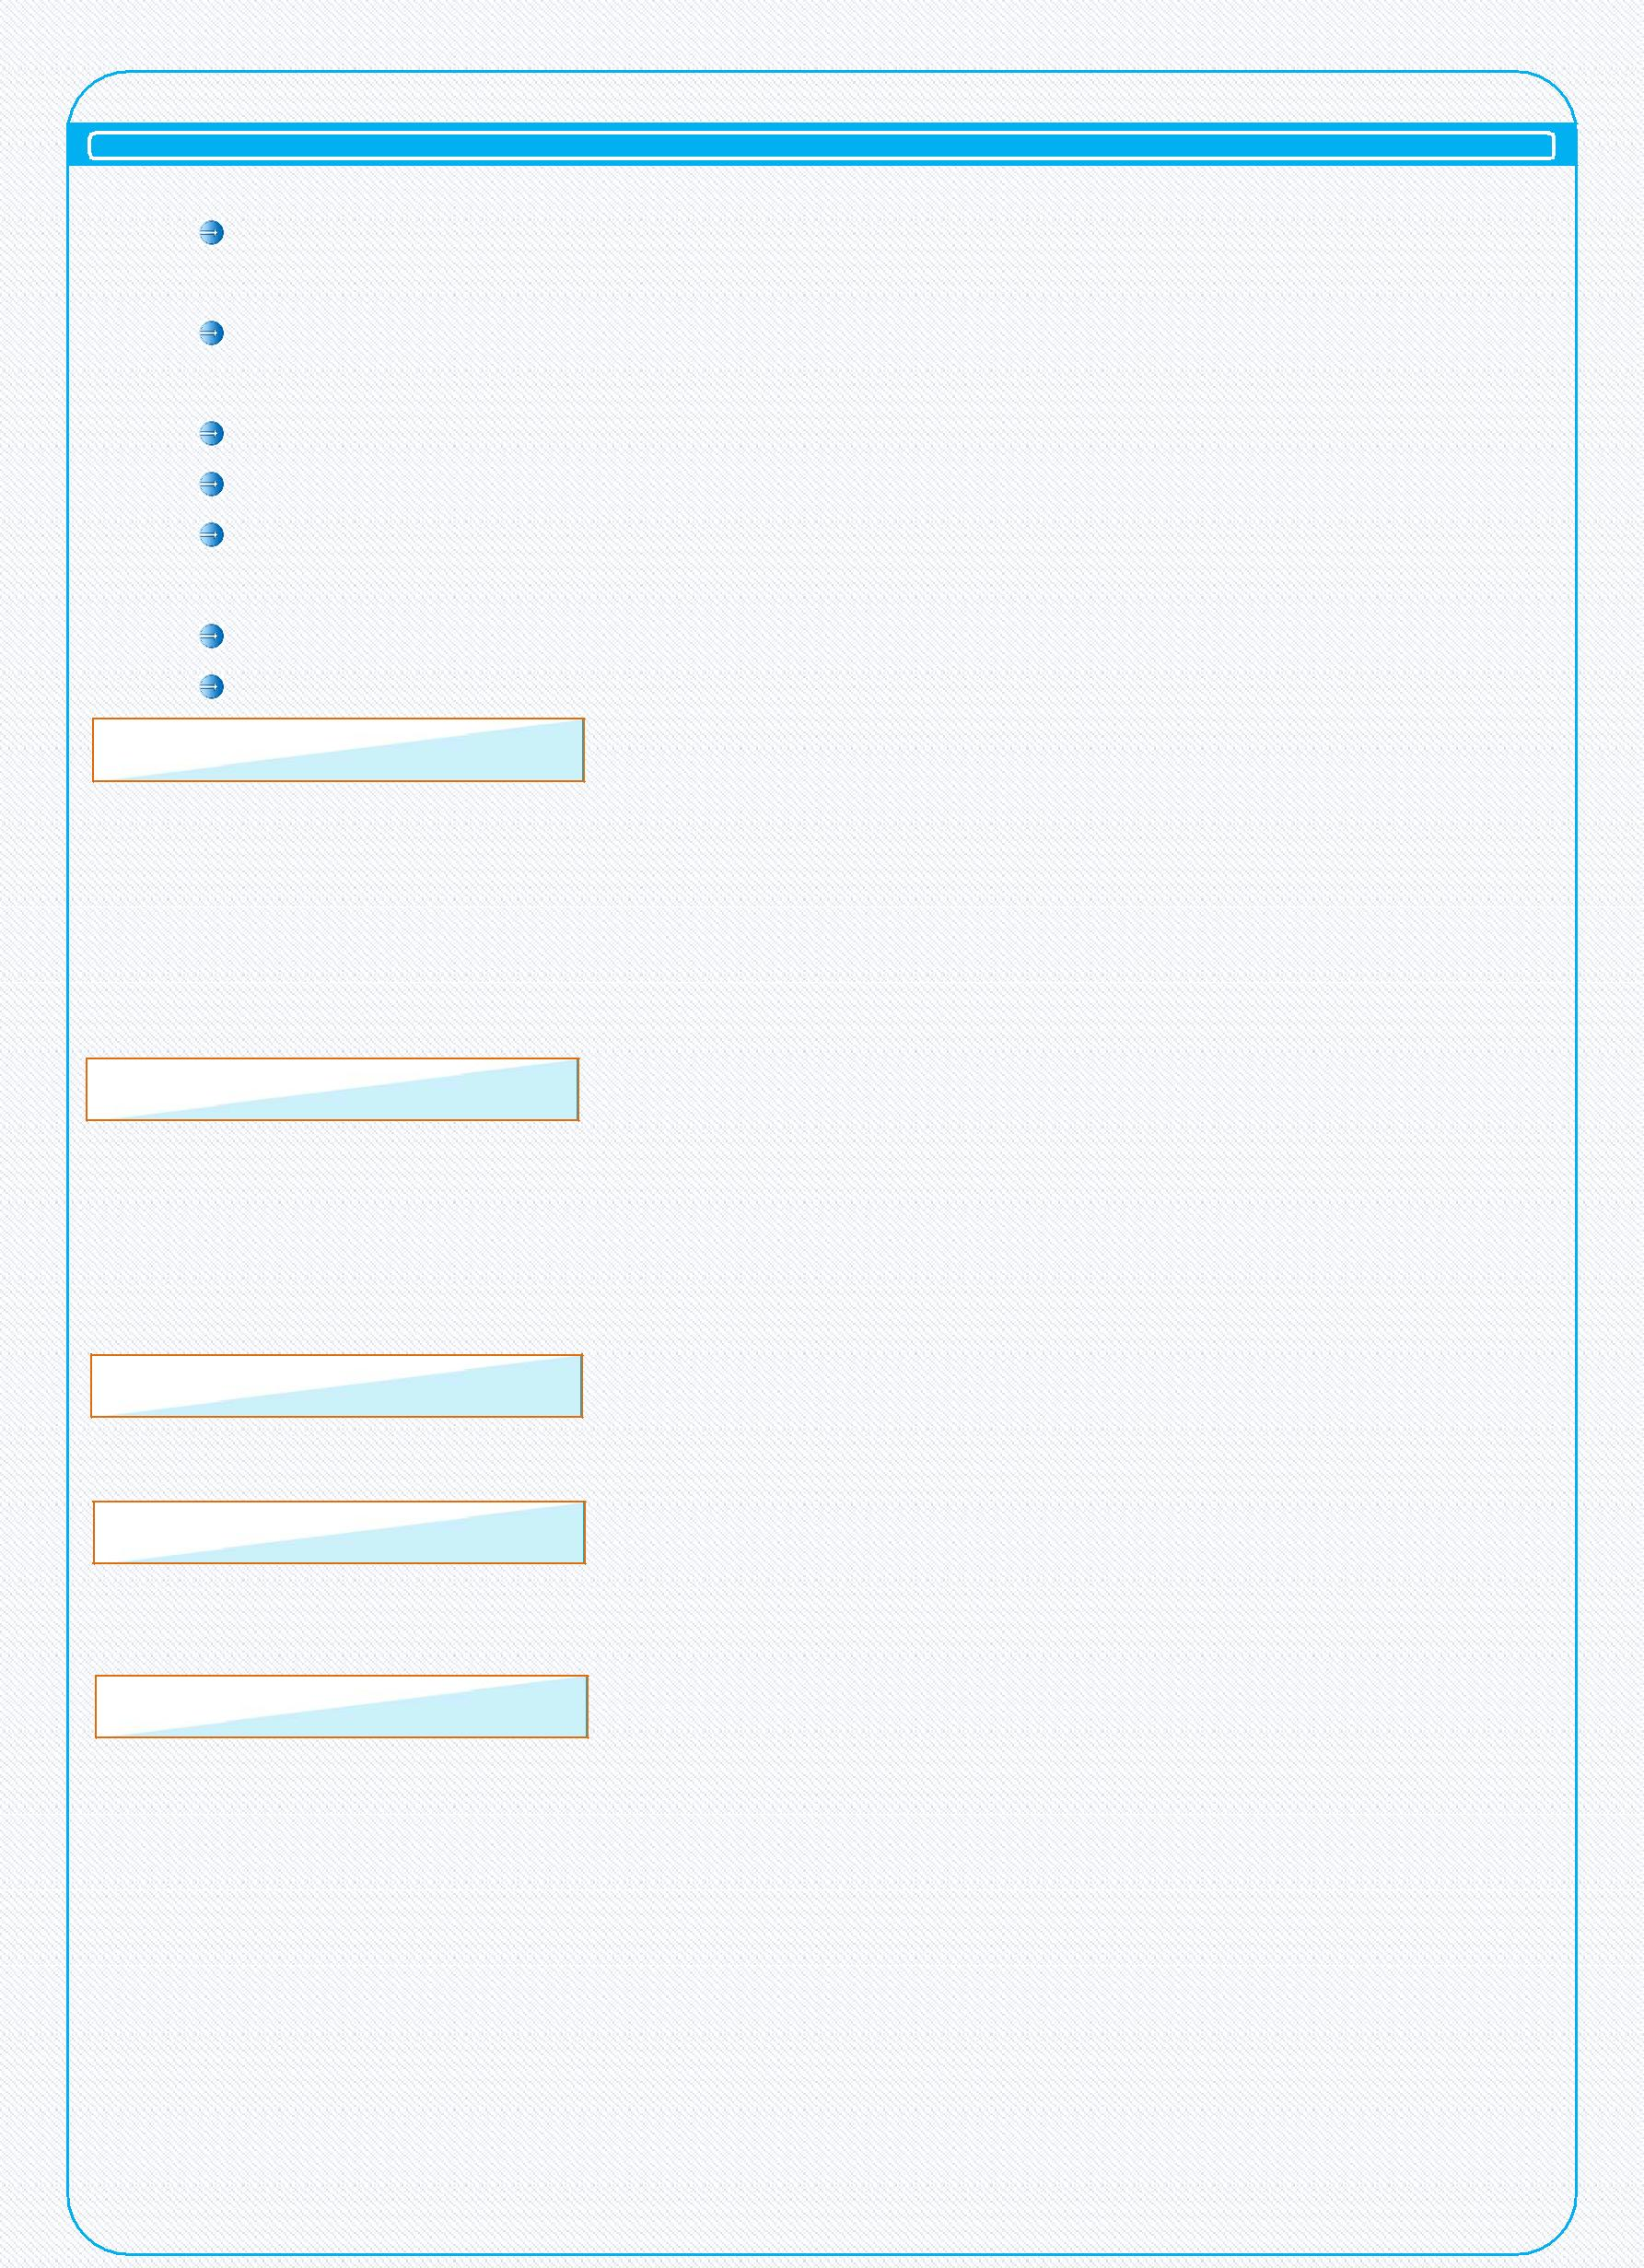
Duties and Responsibilities

Inspecting environment and public areas after they have been cleaned to ensure quality standards.

Making sure that environment hall, corridors and public areas are serviced in accordance with the company standard.

Evaluating, counseling, motivating and coaching employees.

Following all company and safety and security policies and procedures.

Reporting any maintenance problems, safety hazards, accidents, or injuries to senior managers.

Organizing staff rotas.

Report any hygiene issues and following up as necessary.

PERSONAL DETAILS

Name | : | BOLAJI MORUF MAJEKODUNMI
Gender | : | Male
Nationality | : | Nigerian
Date of Birth | : | 12th Dec 1984
Marital Status | : | Single

PASSPORT DETAILS

Issue Date | : | 09th Apr 2014
Expiry Date | : | 08th Apr 2019
Visa Status | : | Employment Visa

LANGUAGES KNOWN

English

COMPUTER KNOWLEDGE

MS Office

Internet & E-mail

DECLARATION

I hereby declare that above mentioned details are true and correct and best of my knowledge

BOLAJI MORUF MAJEKODUNMI

BOLAJI MORUF MAJEKODUNMI – CV No. 1991268
Whatsapp +971504753686
To interview this candidate, please send your company name, vacancy, and salary offered details along with this or other CV Reference Numbers that you may have short listed from

http://www.gulfjobseeker.com/employer/cvdatabasepaid.php
addressing to HR Consultant on email: cvcontacts@gulfjobseekers.com
We will contact the candidate first to ensure their availability for your job
and send you the quotation for our HR Consulting Fees.

