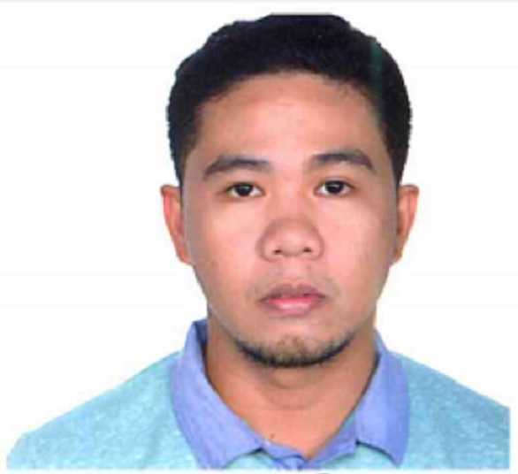
HENRY
HENRY.331954@2freemail.com

APPLIED POSITION: SAFETY OFFICER
JOB OBJECTIVE:
To give the highest possible level of performance required of the job with emphasis on Health, Safety and Sanitation on Environment.
Educational Attainment/background:
Tertiary Level : DMMA COLLEGE OF SOUTHERN PHILIPPINES
Bachelor of Science in Customs Administration
Davao City, Philippines
S.Y. 2008-2013
employment records:
1. position held: safety OFFICER
company : TUManda-bernat construction
softland technologist
(may 01, 2013 to december 15, 2016)
FUNCTION AND MAIN RESPONSIBIL ITIES:

- Responsible for basic health safety and security aspects of the work to be resolved and fixed with the client HSE organization.
- Prepare Hazard identification plan prior to the project start up
- Assisted in this task by the construction contractors & subcontractors safety officers. My main tasks are to:
      - Prepare the monthly accident status report & incident analysis for submittal to the site manager.
      - Obtain from construction contractors & subcontractors, in the conjunction with the site manager, a satisfactory cleanliness / housekeeping of the site.

Other training/seminar/organization:
Member of (IOSH) INSTITUTION OF OCCUPATIONAL SAFETY AND HEALTH

- ASSESSING RISK
- CONTROLLING RISK
- UNDERSTANDING RESPONSIBILITY
- UNDERSTANDING HAZARD
- INVESTIGATING INCIDENTS
- MEASURING PERFORMANCE
- PROTECTING ENVIRONMENT
- ACCIDENTS INVESTIGATION
- HAZARD IDENTIFICATION
Member of (OSHA) OCCUPATIONAL SAFETY AND HEALTH ADMINISTRATION
- First Aid Seminar
- Fire Fighting
- Fire Extinguisher Familiarization and Use
- OSHA – 30 hrs.-To the following HSE training:

- OSHA Act and History
- Personal Protective Equipment
- Confined Space
- Crane Basic
- Electrical
- Excavation
- Fall protection
- Fire protection and Prevention
- Hazard Communication
- Scaffolding
- Stairways and Ladders
- Signs And Barricades
- Hydrogen Sulfide (H₂S)

- Research Methods & Techniques (Customs Administration Department)
- Empowering Customs Students: Shaping Personality for Employment
- Customer Service Excellence seminar
- Values Formation and Integration Workshop
Name | Henry
Date of Birth | April 13, 1991
Age | 26
Country | Philippines
Sex | Male
Civil Status | Single
Citizenship | Filipino
Height | 5’5
Weight | 65 kg
Tourist Visa

