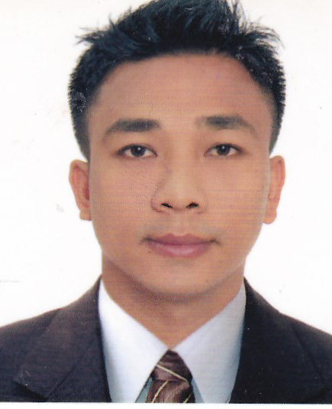

JORGE LABASA RAGASA – CV No. 1991736

A highly flexible individual and an excellent team player with proven ability to work under pressure, I am looking forward to work and contribute my knowledge and abilities for the growth of the company.

KEY SKILLS
- Customer service
- Attention to details
- Punctual and reliable
- Ability to cope and work under pressure

PERSONAL INFORMATION
Birth date | October 29,1980
Civil Status | Single
Height | 5’11”
Weight | 78 kg
Citizenship | Filipino
Visa status Visit Visa December 28, 2016

EDUCATIONAL ATTAINMENT
University of Lasalette Santiago City  (Undergraduate) | Bachelor of Science in Criminology  (1996-1998)
WORK EXPERIENCES:

(September 25,1999 – November 23,2002)

- Welcoming the guest.
- Maintain quality services and ensure consistency in food standards.
- Deliver exceptional guest experiences by taking orders, delivering food and managing all guest request.
- Work closely with customer to create an excellent dining experience.
- Volunteer for additional side work and staying late to managing closing shift duties.

THE PENNINSULA MANILA HOTEL (DOORMAN trainee)
(March 15,2000 - April 30,2000)
- Welcoming the guest upon arrival at the hotel lobby.
- Open and close the door for the hotel guest and offer an assistance.
- Maintain the drive way at all time to ensure the guest satisfaction upon arrival at the hotel.
- Confirmed to the guest their luggage after loading or unloading from the car.

THE PENNINSULA MANILA HOTEL (BELLMAN trainee)
(June 25,2001 – Augost 15,2001)
- Greet the guest upon arrival at the hotel lobby.
- Escort the guest going to room with their luggage.
- Explain the hotel facilities and timmings of the outlet.
- Maintain the standard of the hotel.

SODEXHO COMPANY KSA (Augost 23,2006 – Augost 29,2008)
Head Waiter and Driver
- Assisting customer and providing whatever they need.
- Handling the guest query at all times.
- Handling the guest complain.

LOCKHEED GLOBAL SECURITY AND INVESTIGATION SERVICES INC.
Security Guard –Rockwell Leisure Club Makati City (July 25,2012 up to present)
- Welcome the guest.
- Assist the customer at all times.
- Monitor closely to provide excellent customer satisfaction.
- Follow safety protocols and hotel procedures at all time.

REFERRENCES:
Available upon request

JORGE LABASA RAGASA – CV No. 1991736

To arrange interview with me, please send your company name, vacancy and salary details to my HR Consultant cvcontacts@gulfjobseekers.com Whatsapp +971504753686

______________________________________

