DR VIGNESWARAN M.D.S., D.I.C.O.I.,
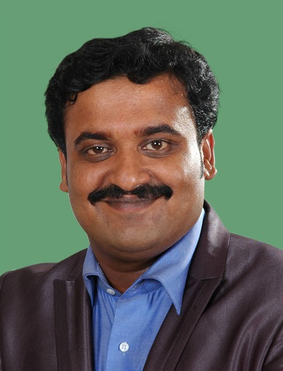
VIGNESWARAN.331966@2freemail.com

Job Applied For Specialist Prosthodontist (DHA Certified)
Work Experience August 2013 onwards (3years and 4 months)
Apollo Hospitals ltd, Chennai, India

March 2011 to July 2013 (2 years 5 months)
Sendhil Dental Clinic & Implant centre, Chennai, India

Educational Training Diplomate in Oral Implantology, (Oct 2016)
International Congress of Oral Implantologists (USA)
SINGAPORE
Fellowship in Oral Implantology (July 2014)
International Congress of Oral Implantologists (USA)
India
Certification in Advanced Oral Implantology(Feb 2014)
Treviso, Italy
Certification in Hands on in Rhein 83 Attachments(Feb 2014)
Bologna, Italy
Master of Dental Surgery (Prosthodontics)(Apr 2008-Feb2011)
Meenakshi University, India
Bachelor of Dental surgery, (Nov 2000-August 2007)
The Tamilnadu Dr M.G.R. Medical University, India

Personal Skills
Mother tongue Tamil
Other Languages known English & Hindi (Read, Write & Speak)
Communication Skills Treating patients from different culture, country, race and language
helped me to develop my communication skills.
Managerial Skills Clinical Head of a Dental Hospital for the past three years, which
has Branches throughout the country, with Dentists of Various
Specialities along with many number of Supporting Staffs all
working under the same roof, helped me to improve my Managerial
skills.
Clinical Skills Diagnosis & Treatment planning.
Executing the planned treatment
General Dentistry
Speciality treatments like Complete Dentures, Fixed Dentures,
Dental implants, Digital Smile Designing, Full Mouth Rehabilitation.
Sterilization & Quality control
Monthly Clinical Audit
IT Skills Expertise in MS office, Smile designing Software, Computed
Tomography Software, Photo Editing Software, Dental x ray
software

Additional Information
CDE Programmes conducted: “Implantology Simplified- Lecture And
Hands On Programme” In 16th Indian Prosthodontic
Society Pg Convention At Vizag In 2014
Simplified Implantology In Pro-Igids 2014 On
20th Sep 2014 Conducted By Indra Gandhi Institute Of
Dental Sciences, Pondicherry

Faculty speaker Fellowship in Implantology at the Manipal University –
Melaka, Malaysia September 2015.

Conferences Organised 1. Organizing Committee - Dicom Guided Implant Surgery, 21st August 2012.
2. Conference Organizing Committee - 40th IPS & 8th Biennial Meeting of
Asian Academy of Prosthodontics Dec 05-09, 20012 Chennai .
3. Organizing Committee - Indian Prosthodontic Society (Tamil Nadu Branch )
Conference , August 31 and 1st September 2013 . Chennai
4. Organizing Committee - Precision Attachments. 28th jan 2011
Professional Affiliation Life member of Dental Council Of India
Life member of Indian Prosthodontic Society

International Congress in Oral Implantologists

PUBLICATIONS: A Comparative Evaluation of Palatal Adaptation in Denture Bases
Processed With Compression Molding and Injection Molding In Two
Different Palatal Configuration-An In Vitro Study
Dr Vigneswaran Sekar* MDS, Dr Sendhilnathan D** MDS,
Dr Lakshmi S,**MDS, Dr Abby Abraham*** MDS, Dr Annapoorni.
H***MDS. IJSRP, FEB 2015 Vol 5,Issue 7, p56 –64

Immediate implant placement following extraction in maxillary
anterior region – A case report
Dr. Monika Sharma, Dr. Abby Abraham, Dr. Vigneswaran .S,
Dr. Lakshmi .S, Dr. H. Annapoorni., IJSRP, JUL 2015 Vol 5,
Issue 11, p54 –60

Influence of Esthetic Dental And Facial Measurements On Patient
Satisfaction Between Genders In Indian Patients
G Selvakumaran, V Sekar, H Annapoorni S Lakshmi, A Abraham,
Tanta Dental Journal Sep 2015

Influence of connector dimensions on the stress distribution of
monolithic zirconia and lithium-di-silicate inlay retained fixed
dental prostheses. A 3D finite element analysis
R.D. Lakshmi*, A. Abraham, Vigneswaran Sekar, A. Hariharan
TDJ, FEB 2015 Vol 12, p56 –64

Comparative evaluation of stresses in tooth implant connected
fixed partial denture by varying the implant design and position: A
3D finite element study
Pratheep KV, Abby Abraham, Annapoorni H, Vigneswaran S
IJDR, NOV 2013 Vol 24, Issue 4, p439-445

Restoring anterior dental aesthetics using zirconium
based All ceramic restorations. A clinical report
IDRR, April 2010 Vol 4, Issue 9, p12 –17

Awards Best Paper Award on "Implant Drills - with Emphasis on Current
Trends"

Annexes Provided on Request
List of all Professional Documents

