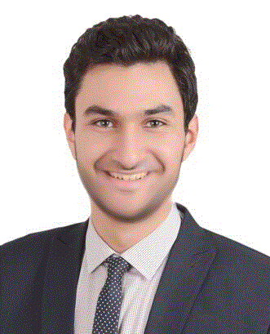
MAHMOUD

ABU

ABU.331970@2freemail.com

☒

Personal Data:
- Nationality: Egyptian
- Date of birth: 14/02/1993
- Driving license: Available (UAE)
- Visa: transferable residency visa (valid till 2018)
☒

Objectives:
- Seeking a role across sales department where my academic knowledge can be further developed and utilized to contribute to the success of the organization I work for.
- I fully understand that medical representatives are basically the link between the healthcare profession and the pharmaceutical companies. This is an important position that I’m confident I can fill successfully Throughout my career I have learned how to provide excellent customer service and I have acquired great interpersonal skills.

☒

Brief of EDUCATION:
- Graduated from Faculty of Pharmacy Cairo University, with a Bachelor Degree in pharmaceutical science and industrial pharmacy in 2014, Grade: Good, GPA (3)

☒

Courses:
- Negotiation with Dr. Ibrahim Elfikky
- Presentation skills, power of listening, and selling work shop authorized by multipharma
- Stress management and community pharmacy by Farabi
- Marketing and selling skills with Novartis.
- pharmaceutical advertising, promotion and leader ship by EPSF

☒

Brief of Experience:

- year and a half experience as a medical representative at Eva pharma co and I
was the best achiever for 2 quarters in a row because of the extraordinary growth in sales in my territory (almost 1000%)
- Training at Sanofi Aventis as a medical representative for 5 months (2013 - 2014)
- Training at Reckitt Benckiser for a 2 month (2012)
- 1 month as a medical representative at Novartis pharma

☒

Technical Skills:
- Microsoft Office: Excellent
☒ o Comprehensive knowledge of general computer software

Language:
- Arabic: Mother tongue
- English: Very good
References furnished upon request

